1

Developing Professional Practice module guide 2019/20

Module Guide

Name of Module
:

Developing Professional Practice

Campus
:

Southend

Full Module Code
:

HS741
-
6
-
SP

Module Dates:

January
–

August 202
3#

Academic
Year:

20
22
/2
3

Student Number:

TBC
Contents

Module Specification

Module Aims, Background & Context

Content

Module Learning and Teaching methods

Module Outcomes

Mapping to Regulatory Body Standards

Assessment

Confidentiality, Anonymity & Plagiarism statements

Resources Required
Essential
Recommended
Journals
Electronic

Marking grids

Timetable

The NHS Constitution Values
The School of Health and Social Care (HSC) is committed to embedding the NHS Constitution values (which are reflected in the University values) and behaviour into all we do. There is recognition that not all students and staff will work within the NHS, however these values are applicable to many areas of work and activities.
The aspiration for those within HSC to involve students, patients, service users, carers and NHS /non NHS professionals in the delivery of all programmes should be the norm. All staff within HSC will demonstrate respect for persons; property and life choices and students are expected to do the same. All staff have a commitment to excellence in education and teaching which invites and acts on student and our partners’ feedback. We expect high levels of professionalism rom staff and students at all times.
The full NHS England Constitution can be viewed at: https://www.gov.uk/government/publications/the-nhs-constitution-for-england
The University Values
The new University of Essex strategy requires that the stated behaviours and values of the university are exhibited throughout your course – these values are similar to the guiding NHS constitution values.
In pursuing teaching, research and support of students within HSC the activity, behaviours and decision making of all members of the academic community are underpinned by clear expectations. These values and behaviours make it clear that the academic community have a responsibility to:
- Aspire to excellence in teaching and research
- Maintain integrity, honesty and openness working within ethical bounds
- Exercise Academic freedom
- Maintain and strengthen the student community
- Demonstrate inclusivity, equal opportunity, respect and dignity.
- Innovate to meet the challenges of a rapidly changing world.
- Maintain a global outlook and ensure that we draw on a rich diversity of perspectives § Work in mutually beneficial partnerships which are based on trust and respect. § Be accountable for decisions made and provide transparency in all.
The full Strategy can be viewed at: http://www.essex.ac.uk/about/strategy/documents/strategic-plan.pdf

Module Title | Developing Professional Practice
Module Code | HS 741-6-SP | JACS code | B751
Date of introduction | 2014 | Academic Year | 2022/23
School | School of Health and Social Care
Terms module taught | Spring and Summer
Module Descriptor  (Used for online Module  Directory) | This module allows student dental therapists to use their clinical practice as a focus for their study and consider this environment by focussing their scholarship, research, and enquiry on enhancing effective clinical practice.
Keywords | Oral health, professional practice, ethics and law, scope of practice, reflective practice, reflection
Module Leader | Jennifer Hagan  MSc DPH, PGCert DE, Dip DTh, Dip DH  Lecturer Oral Health Science  Department of Health and Social Care  University of Essex  E jh22049@essex.ac.uk
Module Tutors | Stephen Pitt; Amalia Khodr; Michael O’Regan; Mayra Crean; Charlie  Greensmith; Jennifer Hagan; Lizabeth Halsey; Arabella Valada Marques, Aylen  Dervish
Module Administrators | Lizzie Norris. School of Health and Social Care. University of Essex, Elmer  Approach, Southend on Sea. SS1 1LW. hhsohlth@essex.ac.uk
External Examiners | Joanne Healy  - University of Edinburgh.

Module Values
NQF Level | 6 | Credit |  | 30 | Learning Hours | 300
Available as Distance Learning? (y/n) |  |  | N

Module Delivery Mode (P) Including total hours per delivery mode
Lecture |  | Tutorial/Seminar | 60
Skills/IT Laboratory |  | Independent Learning | 90
Practice | 150 | Distance Learning

Requisites
Pre-Requisites

None

Co-Requisites/Other Requirements
HS740: Extending Oral Health Practice

Programme Award
BSc (Hons) Oral Health Science

Background / Context
This module is a core compulsory module of the BSc (Hons) Oral Health Science programme. Students will develop their professional practice by focussing on a number of key areas to update their knowledge base, namely ethical principles, legal requirements, scope of practice, communication skills and professionalism. This module will also create an opportunity for the students to consider their current and future learning needs and to reflect on current practice in relation to maintaining high standards of care in their clinical dental environment

Module Aims
By the end of this module the student should have:

- Effective study skills to undertake a programme at degree level
- Developed upon existing key skills to underpin clinical practice, utilising a reflective approach
- Reviewed current legal issues relating to accountability and the requirements of continued professional registration and the need to maintain and develop professional competence and practice.
- Examine clinical governance and other quality assurance initiatives within their professional area of clinical practice
- Fostered an evidence-based approach to patient care

Overview

The module consists of taught sessions by clinical experts in the field of oral health science and dental therapy covering theoretical teaching, linking clinical work-based placement. Teaching is evidence-based and linked to contemporary literature.

Indicative Content
The module comprises the following content:

- Study skills
- Expectations and regulations of DCPs practice
  - Infection control
  - Consent and confidentiality
  - Teamworking
  - Scope of Practice and Standards
- Professional issues in dental practice
  - Using advocates
  - Risk assessments
- Development of self and others
  - Leadership and management
  - Reflective skills
- Communication
- First aid, medical emergencies and basic life support
- Clinical governance and the role of the Care Quality Commission
- Ethics & Law
  - Equality and diversity
  - Discrimination
  - Raising Concerns
- Population based health & care
- The role of evidence in clinical practice

Detailed session content (if available)
Introduction to the module
- Have an overview of the module and how the academic and work-based learning elements work synergistically § Be aware of the content and assessment for the module

Study skills - Guided Learning
- Review own learning styles
- Select learning strategies that take account of personal learning preferences and that are likely to succeed § Employing appropriate and effective study skills
- Reflect on learning in a structured and coherent way and how to use this in placement learning § Develop writing skills for academic assignments and record keeping

Expectations and regulations of DCPs practice - Guided Learning
- Apply the codes of conduct and required personal attributes of being a dental professional by exhibiting altruism, integrity, honesty, responsibility and compassion in the delivery of high-quality healthcare
- Understand the dental team, its roles, responsibilities and accountability to the regulator and the public
- Apply the Scope of Practice of the dental therapist to professional life
- Apply the Standards document to one’s own professional and personal life
- Utilise the dental team appropriately for the management of oral diseases, putting patients interests first and acting to protect them
- Develop teamworking skills, respecting the roles of other members of the dental team, to provide patientcentred care
- Understand how to collaborate with the wider healthcare team

Professional issues in dental practice - Guided Learning
- Understand the rationale for one’s heath status and the effects on professional practice
- Manage safety in dental practice by reviewing knowledge of infection control, substances hazardous to health, reporting of incidents and managing safety of all members of the dental team
- Recognise the importance of risk assessments within a clinical environment
- Work with colleagues who are failing their professional responsibility and how to manages this using a professional approach

Communication - Guided Learning
- Gather and give information with good record keeping and correspondence skills.
- Develop effective oral and written communication skills and apply these to clinical practice, with colleagues and staff, and the general public.
- Develop effective communication in key health messages and breaking bad news
- Modify communication skills as needed for individual patient interactions, recognising anxiety and negative body language
- Recognise when communication is unsuccessful and another strategy e.g. use of an interpreter or advocate, is required
- Be able to communicate effectively with patients with special communication needs

First aid, medical emergencies and BLS
- Have a sound knowledge of how to identify and manage a broad range of medical emergencies as they arise in the clinical environment
- Assess the collapsed patient and perform basic life support
- Provide immediate management of anaphylactic reaction, hypoglycaemia, upper respiratory tract obstruction, cardiac arrest, fits, vasovagal attack, inhalation of foreign bodies and haemorrhage

Evidence based decision making 1 & 2
- Discuss the benefits of utilising an evidence-based approach and how this assists in decision making
- Discuss the principles of evidence-based decision-making
- Recognising the hierarchy of evidence sources and their value in answering clinical issues
- Recognising the limitations of evidence-based decision-making
- Access biomedical information from electronic databases and other resources
- Critically evaluate new knowledge with an understanding of the basic concepts and principles of scientific investigation in oral healthcare
- Evaluate area of own practice by using appropriate methods to gather data and information
- Use information to challenge existing practices and processes and influence others to use evidence to achieve best practice
- Develop informed decisions about diagnostic and therapeutic interventions based on patient information and preferences, up-to-date scientific evidence and clinical judgement

Deepening your reflective practice skills
- Consider the importance of reflecting on and analysing on own experience
- Develop the ability to conduct oneself as a reflective and accountable practitioner including seeking out sources of informed criticism and valuing, reflecting and responding to them appropriately.

Development of self and others 1
- Recognise the role of continuing professional development and the identification of own learning needs
- Recognise key own motivating factors and their importance in sustaining a high level of motivation of self
- Set realistic, appropriate and challenging personal learning goals demonstrating commitment to on-going personal and professional development
- Understand the educational value, tools and skills required to support personal and professional development § Consider own competence and evaluating own capabilities and personal effectiveness

Development of self and others 2
- Define leadership, collaborative working and constructive feedback
- Demonstrate the theories underpinning leadership and collaborative working
- Recognise the significance of own management and leadership role and the range of skills and knowledge required to do this effectively
- Demonstrate the exchange of effective, constructive feedback to others in a respectful, positive environment
- Demonstrate understanding of working with other healthcare professionals in the context of patient care in order to better develop team-working, leadership and facilitative skills.
- Work as part of a high-quality, professional team with the ability to provide and receive appropriate constructive criticism, suggestions and feedback

Clinical Governance 1 & 2
- Have a sound knowledge of the role of the Care Quality Commission and how this impacts practice
- KLOE.
https://www.cqc.org.uk/sites/default/files/20180628%20Healthcare%20services%20KLOEs%20prompts%20and %20characteristics%20FINAL.pdf
- Demonstrate knowledge of local and national procedures relating to clinical governance and poor performance

- Comply with NHS standards and guidance in relation to clinical governance
- Recognizing the importance of valuing and participating in professional audit

Protecting Vulnerable Adults & Safeguarding Children 1 & 2
- Identify vulnerable patient groups
- Describe types of abuse and recognise associated signs and symptoms.
- Outline policy and legislation relating to the protection or safeguarding of vulnerable adults and children § Discuss professional roles and responsibilities in relation to reporting abuse.
- Locate the policy for protecting and/or safeguarding vulnerable individuals in your practice
- Familiarise yourself with the reporting process and identify the key personnel with designated responsibility for safeguarding.
- Identify any local policies in your area of practice that relate to human rights.

Disability, diversity and equal opportunity
- Define the terms equality, diversity, dignity and respect, integrity and trustworthiness, patient choice
- Recognise what constitutes discriminatory practice, giving examples of ways in which individuals different
- Demonstrate respect, compassion and integrity for the patient, society and the profession
- Uphold the principles of individual rights to choose, community’s rights to safety; individual rights to health care against resource constraints
- Recognise when patient advocacy is appropriate and how it may be accomplished effectively

Law and Ethics 1 & 2
- Demonstrate understanding what is meant by ‘ethics in dentistry’.
- Understand the term “profession” and how it relates to ethics in dentistry.
- Become familiar with elements and principles of ethical decision making.
- Understand the ethics of patient relations, delegation of duties, substance abuse in dentistry, financial arrangements, and managed care.
- Understand the difference between dental law and dental ethics.
- Define the normative theories of ethics and apply them to ethical issues in practice.
- Demonstrate knowledge and understanding of ethical principles that guide decisions affecting individual and population health
- Understand and apply the principals of dental ethics to everyday practice.

Consent & Confidentiality Workshop
- State the legal definition of ‘consent’ in the context of dental treatment
- Describe the basic rules of law applicable to obtaining consent to the provision of medical/dental treatment to competent patients
- Describe the practical and ethical bases for seeking consent from patients. Explain the situations in which criminal offences may be relevant when treatment is given without the knowledge or consent of the patient
- Describe the terms assault, battery and negligence as applicable in the law relating to consent
- Explain the professional regulatory rules applicable to consent to treatment
- Know how and who can obtain consent that is valid for treatment and identify which patients are competent to give consent
- Define confidentiality and understand what is considered confidential information
- Understand the outcomes of breach of confidentiality and the responsibilities of a clinician with private and confidential information

Determinants of Health
- Describe the basic principles of a population health approach
- Comment on trends in the UK and internationally
- Identify the demographic and social determinants of health in the geographic area of one’s clinical practice
- Identify how these impact on the health inequalities in the area in which you work
- Discuss how health inequalities are measured, recognise any common patterns and trends and how these inequalities impact the delivery of oral health, and wider healthcare

Inequalities of Health
- Define the concept of health inequalities using examples from the UK and globally
- Describe the evidence base for health inequalities aspects of common conditions that impact on oral health, such as diabetes
- Describe how health policy, health care systems and the wider context of society impacts on health inequalities
- Be able to describe the major problems of health and health care delivery for marginalised patient groups in the UK (e.g. homeless persons, asylum seekers)

Planning the delivery of health
- Review relevant policies and documents to identify needs, and to be able to develop health promotion opportunities
- State how you would plan a health promotion intervention to a group
- State how you would introduce a health promotion intervention to a group.

Evaluating the Role of Health Promotion
- Describe the role of evaluation as part of health promotion interventions to deliver health gain § Identify and develop tools for evaluation and dissemination to assess health benefits

Cultural and Communication Barriers to Oral Care
- Define and describe race and ethnicity
- Define and describe culture and understand what underlies this concept
- Develop and understanding of how a patient’s culture and beliefs will affect their health behaviours such as communication
- Develop an understanding of barriers to care caused by culture and beliefs
- Develop techniques used in overcoming such situations that may be experienced in practice

Handling Complaints
- Know the principles of managing complaints
- Discuss the 8-stage process to deal with complaints
- Look at ways of preventing complaints and explore examples of poor customer service
- Consider the Dental Complaints Service and its role
- Mediate, negotiate and deal with complaints

Raising concerns
- Explore the legal, professional and ethical obligation of a dental professional to raise concerns
- Review current cases and how workplace culture impacts on raising concerns
- Describe common barriers to raising concerns and consider good practice and examples § Identify how to raise concerns and seek appropriate support

Fire Safety - Guided Learning
- Understand basic fire safety and what to do in the event of an emergency
- Understand the principles of fire risk control
- Understand the basics of practical fire safety

Moving and Handling -Guided Learning
- To understand the role of relevant legislation and guidelines relating to safe moving and handling
- To apply the core principles and practice of safe moving and handling to both object handling and to the moving and handling of individuals
- To consider the risk assessment of manual handling tasks and develop an awareness of the legislative requirement for assessments, including the identification of hazards within this process
- To identify measures to reduce the risks of injury to all workers and to understand the importance of ergonomic solutions

Infection Control - Guided Learning
- List the sources of micro-organisms, routes of transmission and key principles of infection control.
- Understand the importance of risk assessment and management in infection control.
- List the essential elements of universal precautions.
- State the importance of correct PPE for healthcare workers

Information Governance and Record Keeping - Guided Learning
- List the rules that should be followed when processing information
- Recognize the importance regarding confidentiality, data protection, freedom of information legislation, good record keeping practice, and information security.

Health and Safety Awareness - Guided Learning
- Understand the importance of health and safety awareness in the workplace
- Know how hazards and risks are controlled in the workplace
- Be aware of the main causes and effects of poor health and safety at work
Learning and teaching methods
Overview:
The module will use different teaching approaches. There will be skills-focussed sessions to enhance specific skills. Clinical and reflective log analysis will provide authentic examples to relate theory and practice. In addition, lectures will introduce key concepts. Individual tutorials, as negotiated between student and academic supervisors and experiential learning in practice-based placements with experienced clinical educators, will further enhance teaching and learning.
Lectures:
Lectures by members of the Oral Health Science team, University of Essex, supplemented on occasions by external experts.
Independent:
Regular guided learning tasks will be set for students using the Moodle virtual learning platform.
Placement:
The student will undertake a clinical placement in a relevant clinical environment (Primary care placement) and will be given opportunities to develop their clinical skills, as well as opportunities to demonstrate competence at the learning outcomes specified for the module’s work-based assessment.
Online:
Discussion forums will be utilised for enhancing learning in appropriate topic areas; reading of evidence-based articles will be available.
Tutorials:
It is expected that the student will meet with their personal tutor at least twice (once per term) during the module.
Students are encouraged to request further personal tutorials at any stage during the module if they feel this is necessary.
Skills:
The aim is for clinical skills to be learned following the Cruess et al (2016) and Miller (1990) models:
Learning Hierarchy | Level of Learning | Learning/Teaching
5 (the highest) | Identity (is) | Work-based learning
4 | Action (doing) | Academic dental clinic/Workbased learning
3 | Performance (shows how) | Skills lab/Academic dental clinic/Work-based learning
2 | Competence (knows how) | Skills lab
1 (the lowest) | Knowledge (knows) | E.g. Face to face teaching, seminars, e-learning

Module Outcomes

On successful completion of this module, the [learner] will be able to:
- accept responsibility for continuing professional development, aware of own limitations and seek guidance and support from colleagues and professional bodies, and demonstrate an ability to critically review, evaluate and update own knowledge, skills and practices in order to keep pace with change.
- Demonstrate understanding of communication as a human interaction and the barriers to effective communication and develop measures to promote positive communication with patients.
- demonstrate knowledge and comply with local procedures for risk and safety management; including infection control, control of substances hazardous to health, fire regulations, safety issues relating to the use of dental equipment and material, reporting adverse events and near misses
- take responsibility for their own safety and the safety of others, including patients, staff and fellow students
- describe and manage a range of medical emergencies.
- describe and discuss the role and responsibility of various members of the dental team and how each role relate to another and the provision of dental care within the different branches of dentistry
- practice within the legislative and ethical frameworks appropriate to the role of DCPs, and the GDC’s standards of conduct, Maintaining Standards; demonstrating professionalism regarding the use of alcohol and recreational drugs; report health problems that affect patient safety and disclose criminal records
- Discuss and apply the concept of patient autonomy, promote patient choice, dignity, privacy and respect, and act as patient advocate in a non-discriminatory manner within clinical practice
- consider the ethical and legal issues in day to day practice, including working with colleagues who are failing their professional responsibility
- demonstrate understanding of the clinical governance arrangements within PCTs and general dental practice, including handling complaints and using complaint as feedback to improve services
- contribute to quality improvement through agreed protocols, clinical guidelines and audit
- demonstrate critical understanding of the legislative and ethical frameworks that protect the welfare and interest of the patients/clients and the rights of health care workers, including the legal principles associated with record keeping, consent, care of the patient with special needs who is unable to give consent; and the legal principles associated with child protection
- demonstrate critical understanding of evidence-based practice and how this affects clinical and professional practice and decision making
- Explain the principles of planning, undertaking and evaluating health promotion in the wider community and how this may impact on the delivery of primary dental care

Mapping to Regulatory Body Standards

This module enables students to meet the following GDC Learning Outcomes as outlined in Preparing for Practice to be able to register as a dental therapist.

1.1.1 Describe the principles of an evidence-based approach to learning, clinical and professional practice and decision making
1.1.7 Explain the potential routes of transmission of infectious agents in dental practice, mechanisms for the prevention of infection, the scientific principles of decontamination and disinfection and their relevance to health and safety
1.5.1 Explain the principles of obtaining valid consent
1.5.2 Obtain valid consent from the patient before starting treatment, explaining all the relevant options and possible costs
1.5.5 Discuss the role of the dental therapist and other members of the dental team in the treatment plan
1.7.1 Treat all patients with equality, respect and dignity
1.7.9 Recognise local referral networks, local clinical guidelines and policies
1.7.10 Discuss the role of the dental therapist and other members of the dental team in the patient management process
1.8.1 Recognise the risks around the clinical environment and manage these in a safe and efficient manner
- Developing Professional Practice module guide 2019/20
1.8.2 Implement and perform effective decontamination and infection control procedures according to current guidelines
1.8.3 Recognise and take responsibility for the quality of care provided to the patient
1.8.4 Take responsibility for ensuring compliance with current best practice guidelines
1.8.5 Recognise and manage medical emergencies
1.10.1 Recognise the responsibilities of the dental team as an access point to and from wider healthcare
1.14.5 Explain the role of the dental therapist in the restoration of teeth
  - Describe the basic principles of a population health approach including demographic and social trends, UK and international oral health trends, determinants of health and inequalities in health, the ways in which these are measured and current patterns
  - Explain the dental and wider healthcare systems dental professionals work within including health policy and organisation, delivery of healthcare and equity
  - Describe and evaluate the role of health promotion in terms of changing the environment, community and individual behaviours to deliver health gain
2.5 Describe the principles of planning oral health care for communities to meet needs and demands
3.1 Communicate appropriately, effectively and sensitively at all times with and about patients, their representatives and the general public and in relation to:
  - patients with anxious or challenging behaviour
  - referring patients to colleagues, particularly where patients are from diverse backgrounds or there are barriers to patient communication
  - difficult circumstances, such as when breaking bad news, and when discussing issues, such as alcohol consumption, smoking or diet
  - Recognise the importance of non-verbal communication, including listening skills, and barriers to effective communication
  - Explain and check patients’ understanding of treatments, options, costs and valid consent 3.4 Obtain valid consent
  - Communicate appropriately with colleagues from dental and other healthcare professions in relation to the direct care of individual patients, including oral health promotion
  - Explain the role of appraisal, training and review of colleagues, giving and receiving effective feedback
  - Give and receive feedback effectively to and from other members of the team
  - Communicate effectively and sensitively by spoken, written and electronic methods and maintain and develop these skills
  - Explain the importance of and maintain accurate, contemporaneous and comprehensive patient records in accordance with legal and statutory requirements and best practice
  - Recognise the use of a range of communication methods and technologies and their appropriate application in support of clinical practice
  - Recognise and act within the principles of information governance
  - Put patients’ interests first and act to protect them
  - Be honest and act with integrity
  - Respect patients’ dignity and choices
  - Maintain and protect patients’ information
  - Recognise and respect the patient’s perspective and expectations of dental care and the role of the dental team taking into account current equality and diversity legislation, noting that this may differ in England, Scotland, Wales and Northern
Ireland
  - Be familiar with and act within the GDC’s standards and within other professionally relevant laws, ethical guidance and systems
  - Recognise and act upon the legal and ethical responsibilities involved in protecting and promoting the health of individual patients
- Developing Professional Practice 2020/21
7.3 Act without discrimination and show respect for patients, colleagues and peers and the general public
7.5 Take responsibility for and act to raise concerns about your own or others’ health, behaviour or professional performance as described in Standards for the Dental Team, Principle 8 Raise concerns if patients are at risk
  - Describe and respect the roles of dental and other healthcare professionals in the context of learning and working in a dental and wider healthcare team
  - Ensure that any team you are involved in works together to provide appropriate dental care for patients
  - Explain the contribution that team members and effective team working makes to the delivery of safe and effective high quality care
  - Recognise and demonstrate own professional responsibility in the development of self and the rest of the team
  - Utilise the provision and receipt of effective feedback in the professional development of self and others
  - Explain the range of learning and teaching methods and the importance of assessment, feedback, critical reflection, identification of learning needs and appraisal in personal development planning
  - Develop and maintain professional knowledge and competence and demonstrate commitment to lifelong learning
  - Recognise and evaluate the impact of new techniques and technologies in clinical practice
  - Accurately assess own capabilities and limitations in the interest of high quality patient care and seek advice from supervisors or colleagues where appropriate
  - Describe and demonstrate the attributes of professional attitudes and behaviour in all environments and media
  - Put patients’ interests first and act to protect them
  - Effectively manage own time and resources
  - Recognise the impact of personal behaviour and manage this professionally
  - Recognise the range of skills and knowledge that contribute to effective management and leadership
  - When appropriate act as an advocate for patient/carer needs
  - Take responsibility for personal development planning, recording of evidence and reflective practice
  - Ensure that all aspects of practice comply with legal and regulatory requirements
  - Demonstrate appropriate continuous improvement activities
11.2 Recognise and respect own and others’ contribution to the dental and wider healthcare team and demonstrate effective team working
11.4 Recognise and comply with the team working requirements in the Scope of Practice and Standards documents 11.6 Recognise, take responsibility for and act to raise concerns about their own or others’ health, behaviour or professional performance as described in Standards for the Dental Team Principle 8
  - Recognise and comply with systems and processes to support safe patient care
  - Recognise the need for effective recorded maintenance and testing of equipment and requirements for appropriate storage, handling and use of materials
  - Recognise and demonstrate the procedures for handling complaints as described in Standards for the Dental Team, Principle 5. Have a clear and effective complaints procedure
  - Describe the legal, financial and ethical issues associated with managing a dental practice
  - Recognise and comply with national and local clinical governance and health and safety requirements

Assessment

Assessment Strategy
Overview
Please see Undergraduate/Postgraduate Handbook for further general information on guidance and support.
These handbooks can be found on the MOODLE page Health & Social Care – Information for Current Students.

Handbook for further general information on guidance, support and rules of assessment. http://www.essex.ac.uk/hhs/documents/current/ug-handbook.pdf

Formative
25 Clinical Logs are carried out in practice during the term to provide supplementary evidence of underpinning knowledge.
Essay Draft to be uploaded by FASER by 12:00 (noon) on 28/06/2023, accompanied by the self-assessment form with guidance required. Submissions sent after this date will not be given feedback.

Summative
The summative assessment for the module comprises an assignment, a SAT and a work-based assessment

- Short Answer Test (SAT) - 2 hours (see timetable)
4 compulsory questions to be answered

This is a standalone assessment and forms 50% of the final module mark

Results will be released no later than 01/09/2023

- Assignment - 2000 words maximum
Must be submitted through FASER by 12:00 (noon) on 21/07/23
Students are required to undertake an assignment of 2000 words (maximum) based on a scenario from the student’s clinical practice. The case study tests the following learning outcomes:

  - demonstrate understanding of the clinical governance arrangements within PCTs and general dental practice, including handling complaints and using complaint as feedback to improve services
  - contribute to quality improvement through agreed protocols, clinical guidelines and audit
  - demonstrate critical understanding of evidence-based practice and how this affects clinical and professional practice and decision making

This is a standalone assessment and forms 50% of the final module mark.

Results will be released no later than 18/08/23

- Work based assessment
Work-based assessments comprise clinical logs, case-based discussions and DOPs. Additionally, students must pass all summative assessments that can be found in the Handbook. These need to be posted onto Moodle and submitted in the portfolio.

Minimum modular pass mark is 50.

Results and feedback from the essay will be available to students by tbc.
Results and feedback from the SAT will be available to students by tbc.
If there is delay in giving feedback the Module Lead should communicate this to students as required.

Assessment Criteria
§ See below for the marking guides for the work-based summative assessments relative to this module.

Learning outcomes: 1, 6 and 7: Online assessment to test understanding and problem solving (formative) (Compulsory completion of all course work)
Learning Outcomes: 1, 2, 3, 4, 6, 7, 8 and 12: Work based assessment (summative)
Learning Outcomes: 9, 10, 11 and 13: Written assignment 50% module weighting
13 Developing Professional Practice module guide 2019/20
Learning outcomes: 2, 3, 5, 6, 7, 9, 11, 12, 13 and 14: short answer test 50% module weighting

Reassessment Strategy
The deadline for the resubmission of failed assignments will be four weeks after the assignment feedback is released. The resubmission deadline will be confirmed when feedback for the first attempt assignment is ready to be released.

Please see the Board of Examiners and Extenuating Circumstances documentation on the ‘Information for current students’ Moodle page for scheduled Boards. The documents are in the ‘Information for all students’ section.
https://moodle.essex.ac.uk/course/view.php?id=7113

Please also see Rules of Assessment for your programme of study:
https://www1.essex.ac.uk/students/exams-and-coursework/ppg/ug/default.aspx
Assessment statement (plagiarism, originality etc)
Confidentiality and Anonymity
All assignments concerned with clinical placements must be completely anonymous and no reference can be made to the name of the hospital, ward or department, or the client’s, their carers or colleagues’ real identities. You must not include any personal information which would allow a person to be identified. Thus it would be normal to change the person’s name, occupation, location or even age etc when submitting your work. Failure to adhere to this requirement could be considered a breach of confidentiality and may be referred to the School’s professional suitability committee.

Any breaches of confidentiality will be managed through the Academic Offences procedures
(https://www1.essex.ac.uk/students/exams-and-coursework/academic-offences.aspx ). If you are unclear about how to manage an aspect of confidentiality please contact the Module Lead who will advise you, before you submit your work.

Plagiarism and Other Academic Offences
The work you submit for assessment must be your original work. It will be subjected to electronic screening which helps to detect plagiarism (i.e. identifying work that has been taken from other sources, such as other student’s work, electronic journals or pages from the Internet, without appropriately referencing and acknowledging the source).
If you are uncertain what plagiarism is please read the information provided on the Talent Development Centre’s
Moodle page on Academic Integrity, Authorship and Plagiarism – and in the relevant Undergraduate or Postgraduate Student Handbook. If you are still uncertain please speak to your tutor. There are a variety of other academic offences (forms of cheating) which it is important to avoid, such as re-using work you previously submitted for another assignment without full acknowledgement or falsifying data or evidence. Further details can be found on the University’s webpage: https://www1.essex.ac.uk/students/exams-andcoursework/academic-offences.aspx
If you are experiencing any difficulties in completion of your work you should speak with your Personal Tutor or Administrator.
The School operates a policy of Extenuating Lateness and Extenuating Circumstances procedures which are available should you require them. Information can be found at:
https://www1.essex.ac.uk/students/exams-and-coursework/ext-circ.aspx

Learning Resources

- Please refer to University of Essex Library referencing guidelines:

https://libwww.essex.ac.uk/referencing.htm
https://www.essex.ac.uk/student/academic-skills/referencing-guides https://0-www-citethemrightonline-com.serlib0.essex.ac.uk

- See the Module page for the Talis Reading List which will identify essential all reading.
- The School has identified Health & Social Care Librarians at both Colchester and Southend Campuses. Details can be found at: https://library.essex.ac.uk/hsc

Marking Criteria
The following marking grids are written with reference to the HEQF Framework:
https://www.qaa.ac.uk/docs/qaa/quality-code/qualifications-frameworks.pdf

For full details of the “HE qualification descriptors” and “Relevant Skills” please refer to the Module Moodle site.

School of Health & Social Care
University of Essex LEVEL 6 MARKING GRID

Student number
Programme |  | Academic level | 6
Module Title
Assignment title
Assessor |  | Date
MARK (%)

 | ü
Either  - Your submission adheres to current published professional and regulatory codes applicable to your programme  (or)  - Your submission adheres to the University of Essex Equality, Diversity Inclusion Policy 2019-2025. |  | Satisfactory
 |  | Areas of concern – in future you must:
 |  | Unsatisfactory - This submission is graded as a 0%. Your work contravenes Code/Policy in the following areas:

Criteria |  | What you should demonstrate. | Comments, as required | Mark
Knowledge &  Critical  Understanding  (Maximum 30%) | • | You have shown systematic understanding of relevant concepts and principles in your field of study.
 | • | You have shown critical understanding of data and analysed these to formulate and sustain an argument.
Application of  Data  (Maximum 30%) | - You have evaluated and interpreted different data relevant to the assignment task.  - You have made critical judgements based on the available data recognising uncertainty, ambiguity and limits of knowledge.
Problem solving  (Maximum 10%) | • You have critically evaluated different approaches to solving problems relevant to the assignment task.
Communication & References  (Maximum 20%) | - You have communicated  clearly, accurately and reliably showing a good attention to detail.  - You have used references accurately and consistently.
Personal  Learning &  Transferable  Skills  (Maximum 10%) | - You have applied the knowledge and skill that you possess in a safe, ethical and critically reflective manner.  - You have highlighted how your personal learning needs may be met and the impact of learning on your practice.
General Observations (optional)

If this module is 2nd marked:  Date:  1st Marker’s mark:  2nd Marker’s name:  2nd Marker’s mark:  Record of reconciliation of grades where required: | If this submission was selected for moderation:  Date:  Moderator name: | If this submission was awarded a fail grade:  Date:  1st Marker’s mark:  2nd Marker’s name:  2nd Marker’s mark:  Record of reconciliation of grades where required:
The pass mark for level 6 assignments is 40% unless otherwise stated in your module guide.

If this is a resubmission assignment; normal capping of marks will be applied by the relevant Examination Board, including, where relevant, any adjustment approved due to extenuating circumstances.

If you believe there has been an error in calculating your final mark or have any questions or concerns about the feedback provided, please contact the module lead in the first instance to discuss this.
Policies and procedures in relation to requesting a re-mark can be found here:
https://www.essex.ac.uk/student/exams-and-coursework/assessment-and-marking-policies

Developing Professional Practice:
2.1
Team working
Learning outcomes The student is able to communicate appropriately in an interprofessional and/or inter-disciplinary context and resolve differences of opinion arising within the dental team so that the patient receives optimum benefit. The student recognises the role the dental therapist play within the dental team in the patient management process.
The scope
In general dental practice
In community dental practice
1 2 3
Unable to vocalise Actively seeking relevant Co-operates effectively findings to other team expertise of others in the with members of the members, particularly provision of dental care dental and wider when these differ from Adopts an open mind, healthcare team in the other clinicians conciliatory approach interests of patients Unable to engage others and prepares to consider Able to create shared in effective team work the views of other dental goals, resolve
Demonstrates little and healthcare differences between understanding of the role professionals team members, working
and expertise of others Generates practical toward patient centred solution to problems care
Aware of ambiguity of
situation presented and able to think around issues

Summative Assessment
Date Placement Grade CE Name
1 2 3

Comments including evidence of performance and competence

Module guide template final 10.14

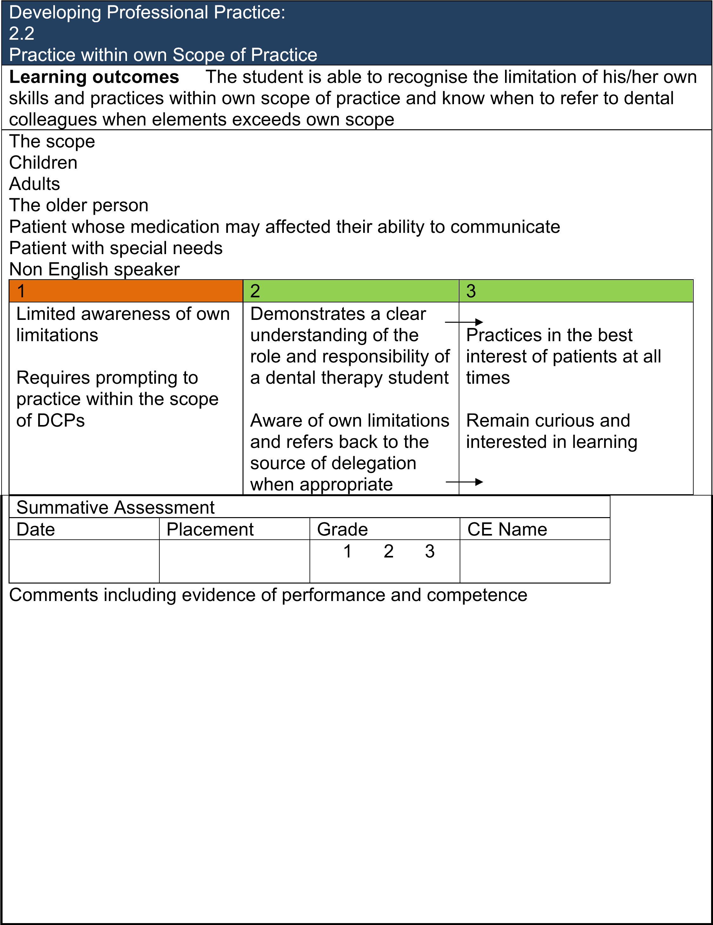

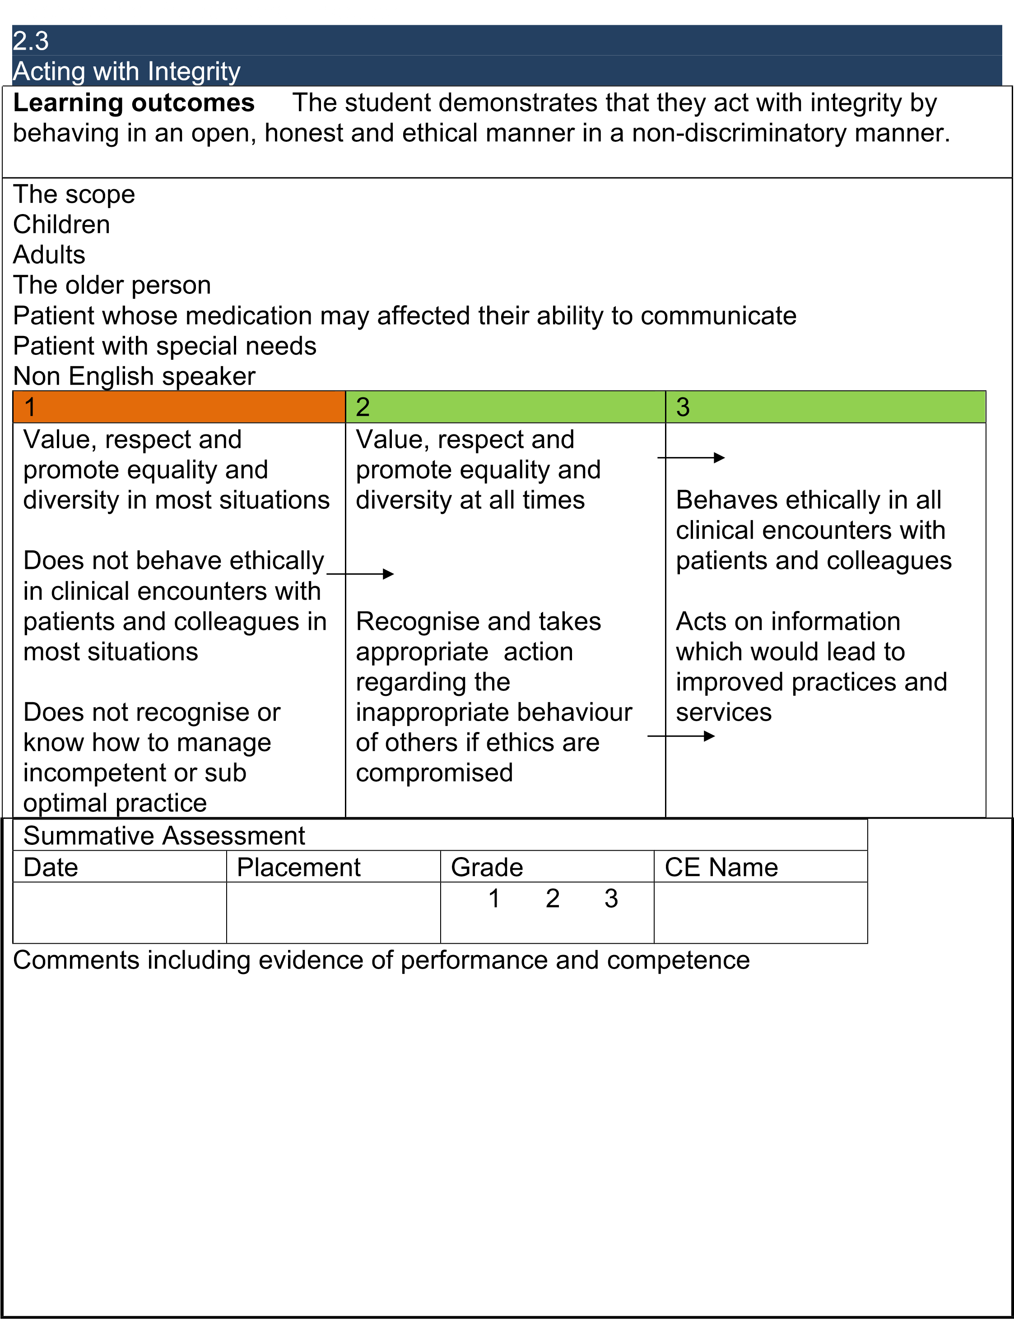

Developing Professional Practice 2.4
Human Rights
Learning outcomes The student is able to provide empathetic care for all patients, including members of diverse and vulnerable populations; is able to respect patient’s dignity and choice and recognises the need for an advocate to act in the best interests of the patient.
The scope
non-discriminatory and non-oppressive practice vulnerable populations In general dental practice
In community dental practice
1 | 2 | 3
Lacks warmth in dealing with certain section of the population, and show little evidence of  understanding patient’s thoughts or feelings | Demonstrated a caring manner and respect for all patients, including the diverse and vulnerable  section of the population  Is perceptive and responding appropriately to patient concerns with understanding  Recognises the need for advocate to act and ensure the best interests of the patient | Able to reassure patients of all backgrounds and culture with appropriate words and action, gaining their confidence and  trusting  Non-judgemental approach to patients from  a diverse background  Able to act as an advocate to act and ensure the best interests  of the patient

Summative Assessment
 | Date | Placement | Grade | CE Name
 |  |  | 1 2 3
Comments including evidence of performance and competence

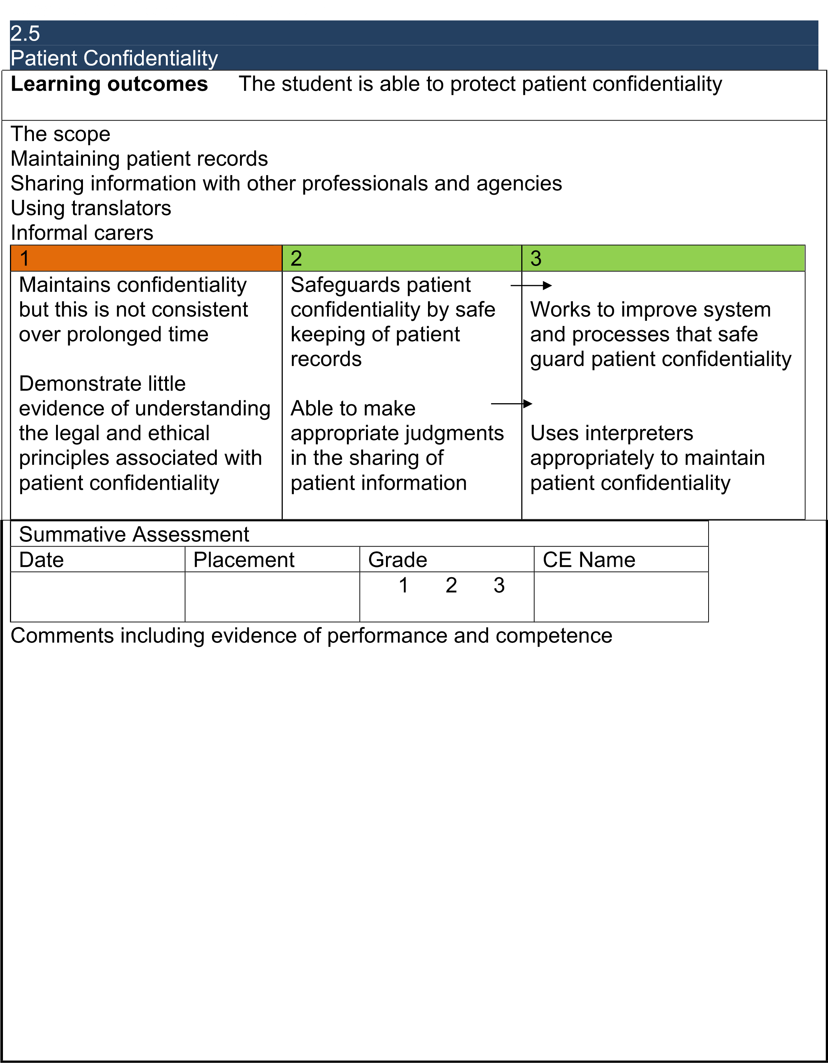

Developing Professional Practice: 2.6
Informed consent
Learning outcomes The student is able to provide the patient with accessible information in order to give informed and valid consent; this includes understanding of treatment to be undertaken, options and costs.
The scope
Children
Adults
The older person
Patient whose medication may affected their ability to communicate
Patient with special needs
Non English speaker
1 2 3
Maintains confidentiality Able to engage patient in Use open, exploratory but this is not consistent a dialogue, using silence questions, enabling effectively, allowing patients to become
Unable to adapt language patients time to express actively involved,
to suit particular needs of thoughts and feelings and dialogue with patients is the situation asking questions prior to enhanced by non-verbal
giving consent for behaviour
Non-verbal behaviour did treatment not facilitate dialogue Respond to questions
Establishes a patient’s openly and appropriately
capacity to give informed
and valid consent Obtains informed and
valid consent
Summative Assessment
Date Placement Grade CE Name
1 2 3

Comments including evidence of performance and competence

Developing Professional Practice: 2.7
Communication with patients
Learning outcomes The student is able to communicate effectively with dental patient’s, particularly with more challenging situations such as anxious, challenging individuals or in discussing sensitive aspects such as breaking bad news, alcohol consumption, smoking or diet.
The scope
Children
Adults
The older person
Patient whose medication may affected their ability to communicate
Patient with special needs
Non English speaker
1 2 3
Able to initiate rapport, Able to initiate rapport, Able to engage patient respond to verbal cues respond to verbal cues using non-verbal and
appropriately appropriately and verbal means in difficult demonstrate empathy and complex situation Is not able to recognise and acting sensitively to
non verbal Recognises non verbal patients needs communication in all communication behaviour situations and the effects encouraging dialogue this may have on patient regarding patient care concerns.

Is able to apply to apply effective listening skills

Summative Assessment
Date Placement Grade CE Name
1 2 3

Comments including evidence of performance and competence

Developing Professional Practice: 2.8
Infection Control
Learning outcomes The student is able to use and clean equipment safely, understand and apply exemplary disinfection, decontamination and sterilisation procedures, complying with current best practice guidelines, and deal with faulty equipment appropriately.
The scope
Children
Adults
The older person
Patient whose medication may affected their ability to communicate
Patient with special needs
Non English speaker
1 | 2 | 3
Unable to recognise faults in commonly used equipment and unaware  of the cleaning procedure | Able to use and clean equipment safely and to a high standard and deal with faulty equipment appropriately  Adhere to current health and safety legislation | Able to use and clean equipment safely, deal with faulty equipment appropriately and put in place a checking procedure to maintain staff and patient safety in the use of dental  equipment

 | Summative Assessment
 | Date | Placement | Grade | CE Name
 |  |  | 1 2 3
 | Comments including evidence of performance and competence

Developing Professional Practice: 2.9
Risk and Safety
Learning outcomes Student is able to comply with national and local procedures for risk and safety management; including infection control, control of substances hazardous to health, fire regulations, safety issues relating to the use of dental equipment and material, reporting adverse events and near misses.
The scope
Infection control
Control of substances hazardous to health
Fire regulations
Safety issues relating to the use of dental equipment and material
Reporting adverse events and near misses
 | 1 |  | 2 |  |  | 3
 | Not familiar with safety procedure, unable to recognise risk and hazards in the working environment and unable to protect self and others from harm |  | Comply with procedures for risk and safety management, able to protect self and others  from harm  Aware of fire evacuation procedure |  |  | Actively promote safe practice, prevent self and others from harm from infection, fire, hazardous substance as a by product of dental practice, and report adverse events and near misses
 | Summative Assessment
 | Date | Placement |  | Grade | CE Name
 |  |  |  | 1 2 3
 | Comments including evidence of performance and competence
Case Based Discussion Form
Student name:
Assessor name:
Date: |  | Practice:
Summary of case discussed:

 | Insufficient evidence |  | Need further development | Competence | Excellence
Practising holistically
Data gathering and interpretation
Making decisions
Clinical management
Working with colleagues and in teams
Maintaining an ethical approach
Fitness to practice
Overall performance
Areas for further development:

Key:
Rating | Explanation
Insufficient evidence | The student’s performance during the discussion shows no evidence to justify being placed on a higher point of this developmental scale.
Needs further development | Rigid adherence to taught rules or plans.  Superficial grasp of unconnected facts. Unable to apply knowledge. Little situational perception or discretionary judgement.
Competent | Accesses and applies coherent and appropriate chunks of knowledge. Able to see actions in terms of longer-term goals. Demonstrates conscious and deliberate planning with increased level of efficiency. Copes with complexities and able to prioritise.
Practising | The student considers the psychosocial needs of
holistically | the patient
Data gathering and interpretation | The student contributes to the collection of clinical data and is able to make sense of clinical findings
Making decisions | The student is able to make relevant and appropriate decisions
Clinical  management | The student makes appropriate contribution to clinical management
Team working | The student works well in a team context
Maintaining an  ethical approach | The student maintain an ethical approach at all time
Fitness to practice | The student is aware of own limitation and seeks help appropriately

Date:
Direct Observation of Procedural/Communication Skill
Student name:
Observer name:
Placement:
Procedure/communication:
Date:
Performance | 1 | 2 | 3
Demonstrates understanding of indications, relevant anatomy, technique of procedure
Obtains informed consent
Demonstrates appropriate preparation pre-procedure
Technical ability
Aseptic technique (if appropriate)
Seeks help where appropriate
Post procedure management
Communication skills throughout the procedure
Consideration of patient/professionalism
Overall performance
Areas for further development:

Please ensure that all boxes are checked. Key:
Rating | Explanation
3 | Independent high standard performance  Does not requires prompts for thinking or action.
2 | Infrequently assisted and satisfactory performance Requires and seeks infrequent prompts for thinking or action.
1 | Dependent & unsatisfactory performance  Requires frequent verbal and physical prompts and direction.

Reflective learning log form
Student name:
Placement:
Supervisor:
What happened
(e.g. who is the patient and why did the patient attend,
i.e. social, medical and dental background and reason for attending)?

What happened subsequently (event after the patient arrived at
the surgery)

What did you learn (from participating and reflecting on the event)

What will you do differently in the future?

What further learning needs did you identify and how and when will you address these
Supervisor
comment

Clinical Log Form:
Relating to Learning Objectives:
Date:
Student name:
Placement:
Supervisor:
Procedure/
Communication
Skills
Patient details: | Gender: | Age: | Language:
Social history
Medical history
Dental history
Procedure/skill
CE comment

Timetable TBC

