E-Mailing students from a previous Academic year – For instance its October 2013 so we are in the academic year 2014/15 but you are wanting to e-mail 2013/14 students going to the November board

Steps

- Logon to ESIS

- Click Student Detailed Inf

- Click Students by Module/any Module within a Dept

- Enter a module code that all the students took in your department e.g. if you wanted to contact all your MA students pick the dissertation code and change the Year to be the previous academic year, in this case 2013/14. Example below:

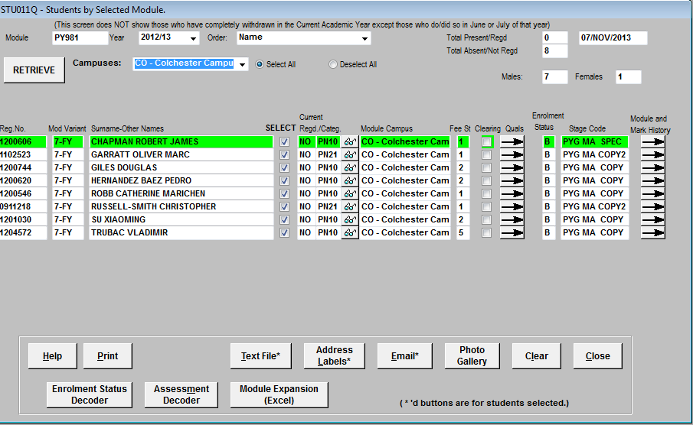

- If you want to deselect a student(s) for any reason the unclick the select button for the students concerned.

- Click on Email, which will bring up the dialog box below
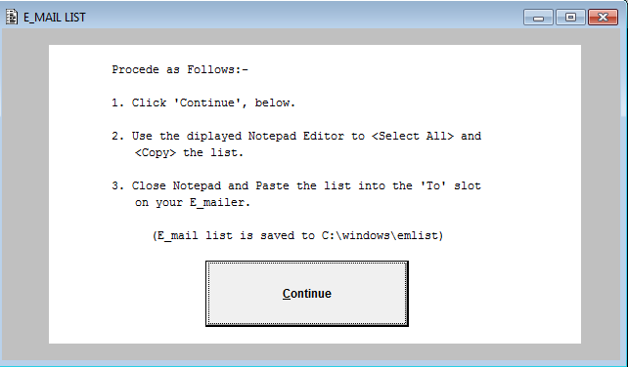

- Click continue
- You will then get a txt file appear with the e-mail address in
- Cut and Paste the e-mail addresses into a BCC box on a new compose e-mail box
- Type your message and send

Note: the e-mail system will only allow 100 e-mails to be sent in this way. If you have more that 100 students the you will need to split the addresses and send more than one e-mail. Please remember each time to put the e-mails in the BCC field

