Enhancement to take the non-submission data in COR where items are entered as NS in place of a mark for non-submitted coursework items as per the Standard COR codes.

This means that you will no longer have to take a note of the non-submissions and type 3/12 AR100 into RPS when it is live.

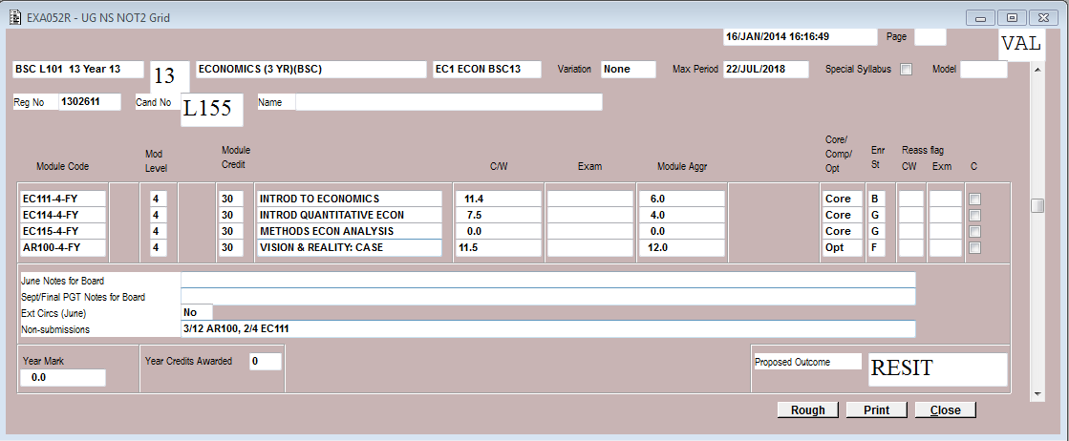

This is a new field that will display the data that has been input into COR. In this example the student had not submitted 3 out of their assignments.

An example of the data in COR is below

