UMAL Online Travel Security Training

Login or Register
The security training is provided by Drum Cussac delivering an e-learning security and awareness training that helps you to recognise and avoid problems when travelling. It is simple to access and provides practical advice on personal security in high risk destinations.
Registration is required in order to have access to the e-learning facility, Travel Prepare which features 6 modules: Basic Travel Security Awareness (duration 30 minutes); Natural Disasters; Information Security Abroad; Avoiding Bribery and Corruption when Travelling; Female Traveller Security and Kidnap (duration 15 minutes). You can do the training in one go or individually as you can leave the training and pick it up at a later time.
The requirements for the registration process are set out below to walk you through the sections with screen shots in step-by-step fashion.
If you have previously registered the following address takes you directly to the log-in screen: https://travelprepare.drum-cussac.net/login/index.php
Please note that a separate registration process is required for the RiskMonitor Traveller. This information is essential for your overseas travel risk assessment and the link for access is: www.drum-cussac.net. This link allows you to sign up, if you will be accessing the real-time alerts for the first time, with country analysis and advice specific to a wide category of threats. Screen shots with step-by-step details which walk you through the registration process to set in motion your overseas travel risk assessment via RiskMonitor Traveller are available in the UMAL Drum Cussac online Risk Monitor
Registering for Travel Prepare training
Visit https://travelprepare.drum-cussac.net/login/self-registration.php
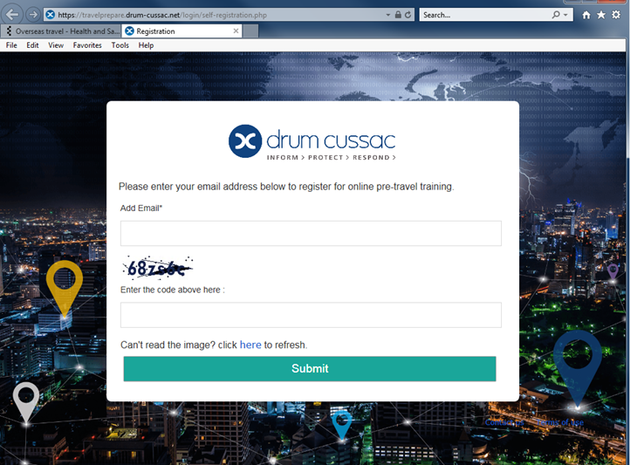 see next page for guidance steps
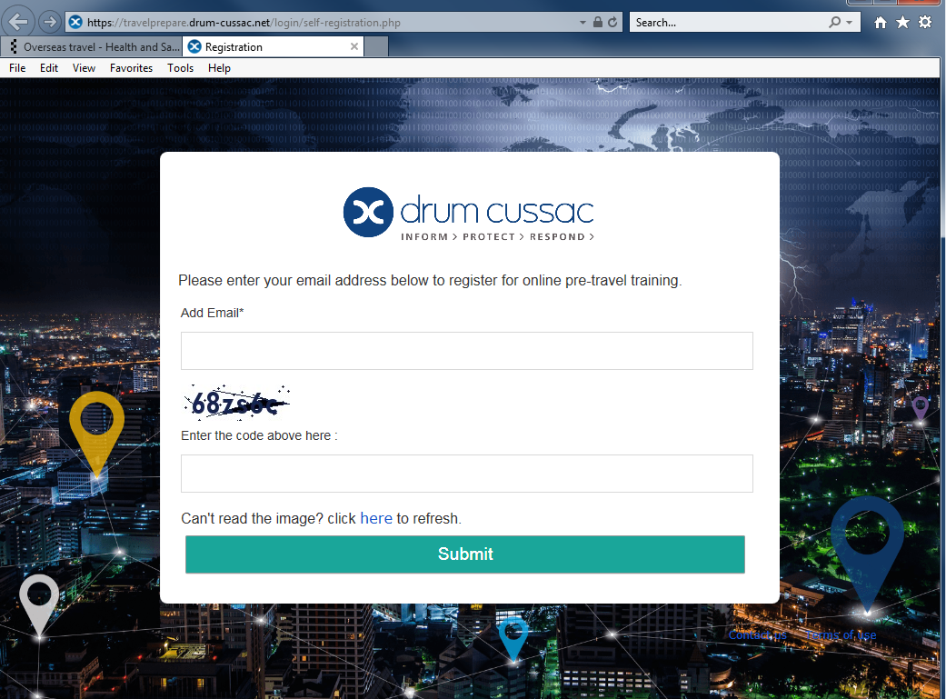
To register you will need to use your University of Essex e-mail address in the Add Email box.
Use the numbers or letters displayed under the e-mail box – these are the code that you are required to Enter.

If you cannot read the code/image click on ‘here’ and this will refresh the code. You will be shown a replacement selection of numbers and/or letters for the code.

Once you have completed your entry of: 1) e-mail address, 2) the code information
click on Submit
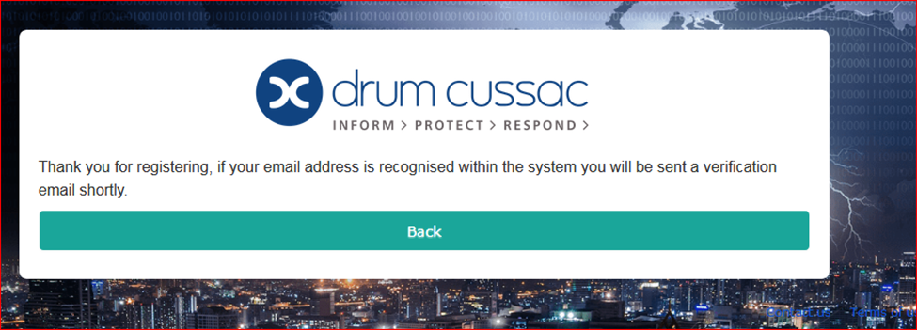

You will receive an e-mail message to your University of Essex e-mail address asking for you to complete the Drum-Cussac TravelPrepare verification – this step

verifies that you are using an @essex.ac.uk account. After you receive this message on screen and if you then do not receive the follow-on e-mail verification, please check your junk mail box. You will need to move the message from junk to your inbox to use the links.
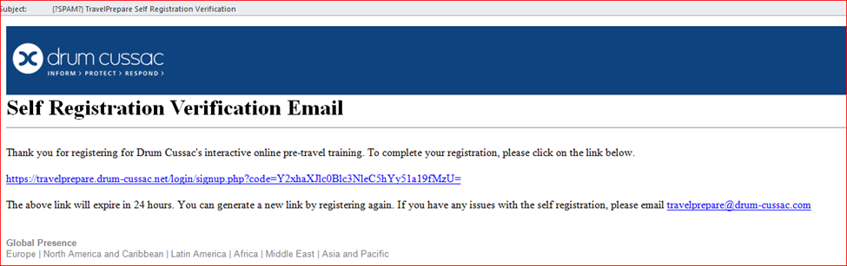
When you open this e-mail you will need to click on the link given to complete the verification step of your registration. This will take you back to the Drum-Cussac website where you will need to fill out another form in order to complete your registration.

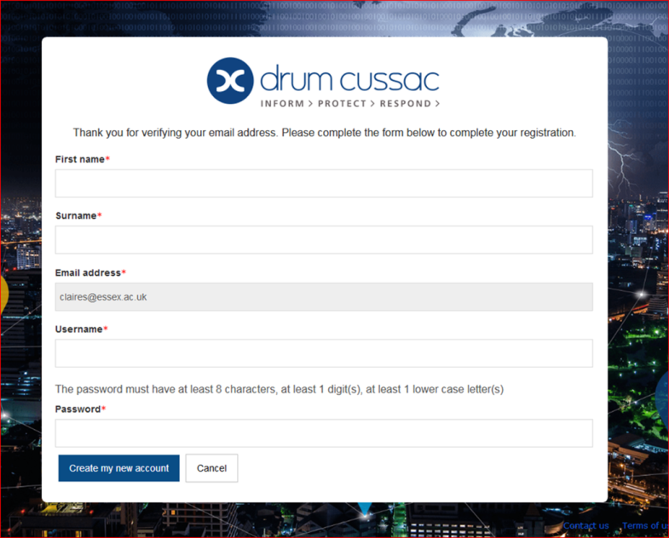

See guidance for completion on the next page.
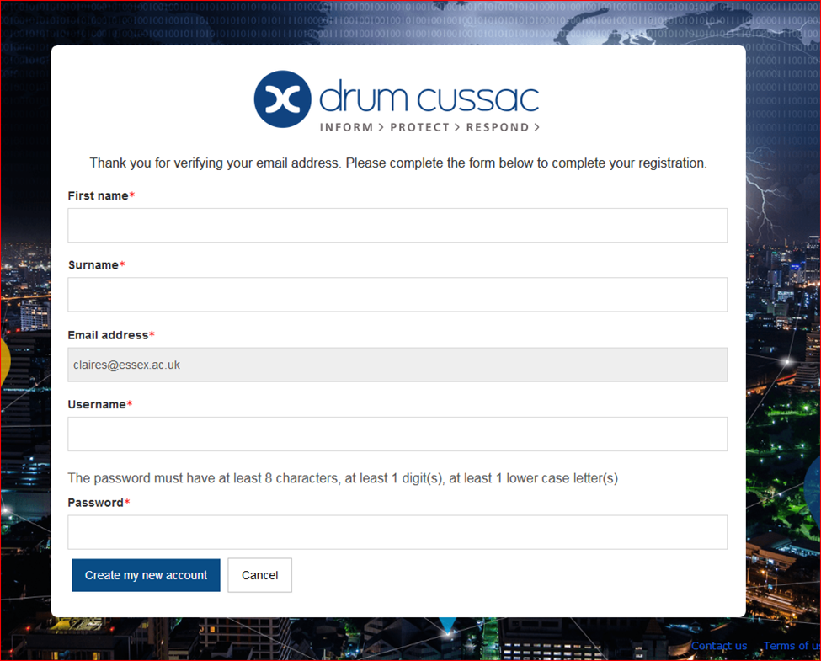

You need to enter first name and separately in the next box your last name(s)
Re-enter your University of Essex e-mail address
Create a User name that you using when visiting this website
Create a Password that you will be using when visiting this website – include at least one digit and at least one lower case letter.
Once all items complete press Create my new account

Now you have completed registration the following address will take you directly to a log-in screen for future visits: https://travelprepare.drum-cussac.net/login/index.php

Training modules
On the Dashboard ‘landing page’ there is a selection of 6 x training modules available for you to access/ Launch in order to prepare for your Overseas Travel
- Basic travel security awareness (30 minutes)
- Natural disasters
- Information security abroad
- Avoiding bribery and corruption when travelling
- Female traveller Security
- Kidnap and Ransom. (15 minutes)

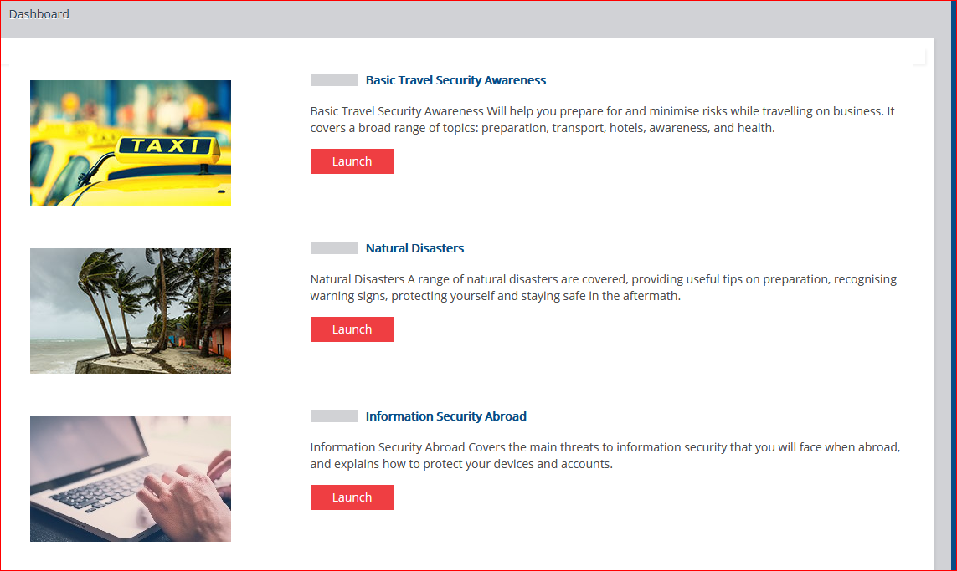

Appropriately targeted travel training courses are notified to those travellers visiting countries, cities or risk areas where the Drum Cussac Country risk rating scores are greater than 3. This notification is sent by Insurance and satisfactory completion is mandatory.
However, should you opt to complete the suite of courses when not stipulated by Insurance due to lower risk rating scores, the courses will be available for you to selectively access.
In all instances (mandatory or selective completion) please ensure you retain the training completion certificates you will be issued on-line as these must be shared by you with Insurance via e-mail notification: (insurance@essex.ac.uk). Traveller’s training is valid for a 3-year period from the certificate date. Insurance will however, prompt for training to be completed / repeated if they do not receive and record each traveller’s training certificates within the required timeframe.

Once you have selected to Launch the training course the background information will take some time to load before you arrive on the ‘Welcome’ screen. This gives an indication of the duration of the course but confirms the option to save and re-start as may be necessary.

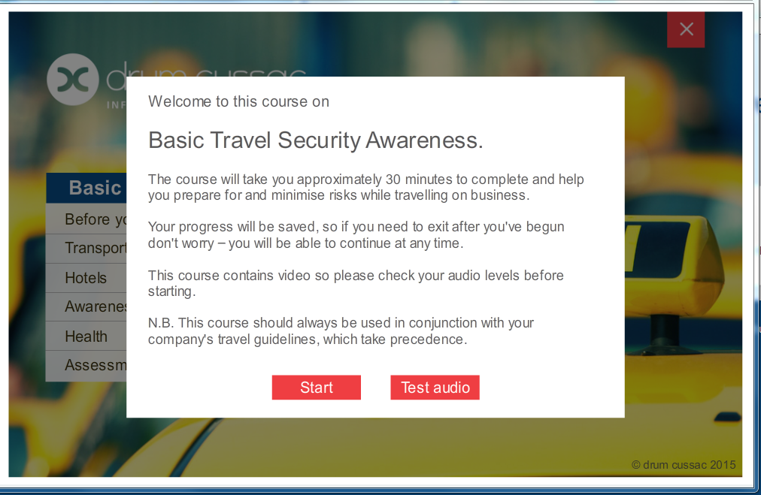

At completion a Course Certificate is available for your records to show completion and a copy of this should be retained as it may be required to support your risk assessment and the approval sign-off for your trip.
As stated on the previous page a copy of the certificate(s) must be shared with Insurance via e-mail notification: (insurance@essex.ac.uk). Traveller’s training is valid for a 3-year period but Insurance will prompt for training to be completed / repeated if they do not receive and record each traveller’s training certificates within the required timeframe for a trip. Training certificate validity of 3-years is taken from the elapsed time from the date on the certificate.

