Curriculum Update:
Teaching, Learning and Assessment
This guidance is aimed at both academic and professional services staff that are involved with the review and submission of updated courses and modules. All courses and modules are updated annually as part of the ongoing cycle of monitoring and review.
This guidance is part of a series of themes:
- Theme 1: Curriculum Update overview
- Theme 2: Consultation and justifications
- Theme 3: Teaching, learning and assessment
- Theme 4: Late changes
This guidance includes:

Further advice and guidance
- Further advice and guidance are provided on the system and how to request changes. Timelines are provided in Theme 1: Curriculum Update Overview.
- The External Engagement Framework enables Departments to consider which level of external consultation changes to courses and modules require.
- The Framework for student consultation and notification on course and module changes enables Departments to consider the types of change that require student consultation and notification.
- The Organisational Development team produce a range of resources which help staff who are designing courses and modules.
- Quality Assurance Agency (QAA) UK Quality Code for Higher Education: Advice and guidance: Course design and development (November 2018)
- Higher education course changes and closures: statement of good practice (November 2015)
- Quality Assurance Agency (QAA) Guide to providing information to prospective undergraduate students (2017)
Support
- The Course Records Team run a Virtual Office during the Curriculum Update period.
- If you have any queries about any of the information in this document or would like to discuss possible changes before submitting them, then please contact the relevant QUAD Manager:
Assessment types
Framework of Assessment
- In 2021/2022, a framework for assessment was approved by Senate which aims to ensure our approach to assessment supports every student from every background to achieve outstanding outcomes.
- This approach is in line with the wider Education Strategy aims to ensure our curriculum and approach to assessment are inclusive, innovative, impactful and reflect our global learning community.
- As a result of learning during the pandemic and the review of alternative assessment, it was decided that open-book assessments should replace closed book assessments, except where there was a good case for retaining these, in which case Faculty Dean approval is required. For example, this could be where the learning outcome tests memory or to fulfil PRSB requirements.
Assessment definitions
Exam Style:
- Remote – the student takes the assessment in any location and not in a designated, physical exam environment (place). An internet connection is required to access the assessment, but the work can be completed either online or offline. The assessment is either of short duration (less than 24hrs) or 24/48/72 hrs. The shorter duration exams could be computer-based.
- In-person – the student takes the assessment on campus in an invigilated exam venue. This is a timebound assessment in controlled conditions. The exam could be computer-based (depending on capacity).
Exam Book:
- Open-book (unrestricted) – the student may access any open book materials to support them to answer the assessment. The work must be the student’s own and guidance on the expected approach to referencing will be provided.
- Open-book (restricted) – this applies in the case of in-person exams where the student may only bring specified open book materials into the exam. Departments can check with the Exams Office (exams-staff@essex.ac.uk) as to whether materials are suitable.
- Closed-book – this applies in the case of in-person exams where the student is not allowed to bring any open book materials into the exam. Closed-book exams require Faculty Dean approval.
Open Book Materials:
- Online/electronic - subject materials such as electronic lecture/lab notes, electronic study/revision notes, internet resources, e-textbooks and online calculators/dictionaries. These resources are accessed via the student’s own device(s).
- Paper based - physical subject materials such as study notes, textbooks, translation dictionary for language exams and formulae/crib sheets provided by the department.
Exam Location:
- Departments must select an exam location. In the case of computer-based exams this includes the type of software the exam will be released and completed with, and any requirements such as large desk for in-person, handwritten exams. See the appendix for further guidance.
Exam Managed by:
- Centrally Managed – the Exams Office timetables the assessment and manages collation and distribution of exam papers and any invigilation. Exams take place in the main exam periods.
- Department Managed – The assessment is timetabled and managed by the Department.
Changes for 2023/24 onwards
- As feedback emerges from the first year of hybrid exams in 22/23, additional guidance has been provided to assist Departments to select the correct exam style, book and location for each exam assessment. Further clarification has been provided on the different types of exam resources and whether these are permitted for use in open book (unrestricted), open book (restricted) or closed book exams.
- Requests for closed book exams still require a rationale to be provided and Faculty Dean approval.
- Additional information, including examples of exam scenarios can be found in the appendix.
Exam types & permitted resources
The following table provides an overview of the different resource types and the types of exams that they can be used in:
 | Remote  Open Book (Unrestricted) | In-Person  Open Book (Unrestricted) | In-Person  Open Book (Restricted) | In-Person  Closed Book
Online/electronic open book subject materials via student’s own device(s) such as:  Electronic lecture/lab notes, electronic study/revision notes, internet resources, e-textbooks, online calculators/dictionaries | Any permitted without restriction | Not permitted (no devices) | Not permitted (no devices) | Not permitted (no devices)
Paper-based open book subject materials that students can bring such as:  Study notes, textbook(s), translation dictionary (languages exams only), formulae/crib sheet (from Department) | Any permitted without restriction | Any permitted without restriction | Only items specified by Department | Not permitted
Exam tools that students can bring such as:  English language dictionary, translation dictionary (non-language exams), approved calculator | Any permitted without restriction | Only items specified by Department | Only items specified by Department | Only items specified by Department
Reference materials provided for the exam paper such as:  Data/reference tables or case study | If provided by Department | If provided by Department | If provided by Department | If provided by Department
Study Notes for In-Person Exams
- Departments cannot apply a page limit for in-person, open book (unrestricted) exams.
- Departments can specify a page limit for in-person, open book (restricted) exams only.
- Where no page limit is specified, students should be advised to prepare short, well-structured study notes.
Textbooks for In-Person Exams
- Departments cannot restrict the title/number of textbooks for in-person, open book (unrestricted) exams.
- Departments can specify the title/number of textbooks for in-person, open book (restricted) exams only.
- Students predominantly access textbooks online. With devices not permitted during in-person exams, fair and equal access to textbooks becomes a consideration.
- Departments should advise students that textbooks, where permitted, are not required to answer the exam and do not need to be purchased.
- Otherwise, Departments should seek guidance from the Library on how to provide students with any textbooks/extracts deemed essential for an exam.
Formulae Sheet for In-Person Exams
- A formulae sheet, while generally provided as part of the exam paper, is considered an open book material.
Translation Dictionary for In-Person Exams
- A translation dictionary is considered an open book material for language exams only.
For example:
1. A French exam only permitting the use of an English/French translation dictionary would be classed as open book (restricted).
2. A Maths exam only permitting a foreign language to English translation dictionary (perhaps to assist incoming study abroad students) would be classed as closed book.
Invigilator Checks
- The invigilator will check the resources a student brings to the exam match the permitted items on the Print Authorisation Form (PAF).
- The invigilator will ensure students comply with the exam rules on the usage and storage of resources during an exam. For example, the student is not permitted to store extra notes/books under the desk or obscure the invigilator's view of the exam paper.

What actions do departments need to take?

Who do we contact if we need further guidance?
- Departments can check with the Exams Office (exams-staff@essex.ac.uk) to clarify whether proposed exam materials are suitable and also for further advice on the different types of exam style, book and location.
- Departments can also contact their QUAD Manager or quad@essex.ac.uk for further guidance.

Coursework types

The following coursework types were agreed by Senate. As with exams, any closed book assessment requires Faculty Dean approval.
Coursework
Open book In-person timed test, invigilated (default) | Tests are classified as coursework. They are scheduled in a student’s teaching timetable and are undertaken in controlled conditions. The approach to invigilation varies. Could be computer-based.
Closed book in-person timed test, invigilated (requires Faculty Dean approval) | Tests are classified as coursework. They are scheduled in a student’s teaching timetable and are undertaken in controlled conditions. The approach to invigilation varies. Could be computer-based. Faculty Deans must consult with the Academic Registrar and PVC (Education).
Open book remote test | Remote assessment but scheduled in a student’s teaching timetable. Could be computer-based
Open book coursework (includes presentations, essays, projects etc.). | Deadlines are set by the department and published in advance.

Adding new types of assessment
- Departments are permitted to introduce a wide range of assessment methods with the approval of the Quality and Development (QUAD) team, or Faculty or Partnerships Dean.
- In the case of modes of assessment not previously used in the University, the Faculty or Partnerships Dean will also be involved in the initial approval process.
- The University wishes to encourage its departments to broaden the range of assessment methods used. (Group assessment, self-assessment, portfolio assessment and online assessment are examples of modes of assessments which might be implemented more widely.)
The following information must be provided via Curriculum Update when introducing new types of assessment.
- Assessment type must be provided; e.g. essay, report, test, blog, podcast. This information has to be published to students.
- A brief description of the new assessment, including word count/duration and how the assessment will be marked.
- Opportunities for formative assessment (if it is a completely new assessment type for students).
- Will reassessment be like-for-like?
- Which module learning outcomes the assessment covers, or if learning outcomes need to be changed.
External and student consultation – depending on scale of changes to assessment this may be needed.

Teaching, learning and assessment overview

What is the aim of the teaching, learning and assessment overview?

The aim is for all departments to have a teaching, learning and assessment overview which can fulfil the following functions:

- Provide an overview to current and prospective students of the teaching, learning and assessment methods used in the department;
- Form the basis for discussions within the department, and during quality enhancement meetings, to formulate teaching, learning and assessment plans as well as embedding new initiatives for future academic years
- Support academic members of staff in designing, developing, and delivering new courses and modules
- Provide a standardised approach to learning outcomes to ensure that they are at the appropriate level and volume of credits
- Assist with internal/external review or accreditation requirements since it could be referred to without having to create something new
- Set the scene for the annual Curriculum Update which would enable more efficient approval of changes by the Faculty Deans and the Quality and Academic Development team and would also assist with compliance with CMA and other external regulations.
The overview should cover:
- each level of provision (undergraduate and postgraduate taught and research)
- all modes of delivery (including online/blended study)
- both assessment and reassessment.
Why do we need this overview?

As detailed in various policies, including the University’s Marking Policy, departments should have an assessment strategy for each course, or set of courses, for approval in the annual monitoring process and periodic review. Departments are also asked to provide documents which reflect on approaches to learning and teaching in Periodic Reviews.
The University is also required to publish a broad overview of teaching, learning and assessment methods for each department to current and prospective students, in order to meet CMA requirements.

What actions do departments need to take?
TLA Overview for students
The information contained in the student overview is core and aligns with CMA requirements. This information will be published to prospective and current students and will appear on Curriculum Notifications.
What should be included?
For each level of provision, Departments created a brief overview that is sent to prospective and current students. The student overview should include:
- Details about the general level of experience or status of staff involved in teaching
- Overall methods of assessment (for example, a combination of exams, coursework, or practical assessments)
- Overall expected workload/contact hours (e.g. frequency/duration of lectures and seminars)
- Departments will be provided with an example of the student overview for each level of provision (the undergraduate example is provided below). Text highlighted in green is an example of how the department could operate.
- Departments are asked to revise these statements and amend them as necessary.
Undergraduate  Following the impact of the pandemic, we made changes to our teaching and assessment to ensure our current students could continue with their studies uninterrupted and safely. These changes included courses being taught through blended delivery, normally including some face-to-face teaching, online provision, or a combination of both across the year.  The teaching and assessment methods show what is currently planned for 2022 entry; changes may be necessary if, by the beginning of this course, we need to adapt the way we’re delivering them due to the external environment, and to allow you to continue to receive the best education possible safely and seamlessly. | This section will be published to prospective and current students and will appear on Curriculum Notifications. It’s also core CMA information.  The Teaching and learning disclaimer is standard wording for all.
The Department’s approach to teaching, learning and assessment is [responsive to the varying needs of students from different backgrounds and with different learning needs]. | Revise - General approach to teaching, learning and assessment
Our courses draw extensively on the expertise of staff within the Department. [The majority of staff are research active scholars publishing in internationally renowned journals. Some research students work as Assistant Lecturers to help with the delivery of modules]. | Revise – General level of experience or status of staff involved in teaching
A variety of assessment allows for the testing of a range of skills and learning outcomes. Assessed coursework will generally consist of [essays, take-away exams, blogs, individual or group oral presentations, and small-scale research projects, as well as open book examinations]. | Revise – Overall methods of assessment
Students would typically attend [a one-hour lecture and a one-hour seminar for each module every week]. Seminars would usually have [about 20 students]. A blended learning approach has been taken this year where students can access materials and recorded lectures via the Virtual Learning Environment (VLE). | Revise – Overall expected workload/contact hours

If you have any questions then please contact QUAD via quad@essex.ac.uk.
Snapshot

Appendix: Determining exam book and style
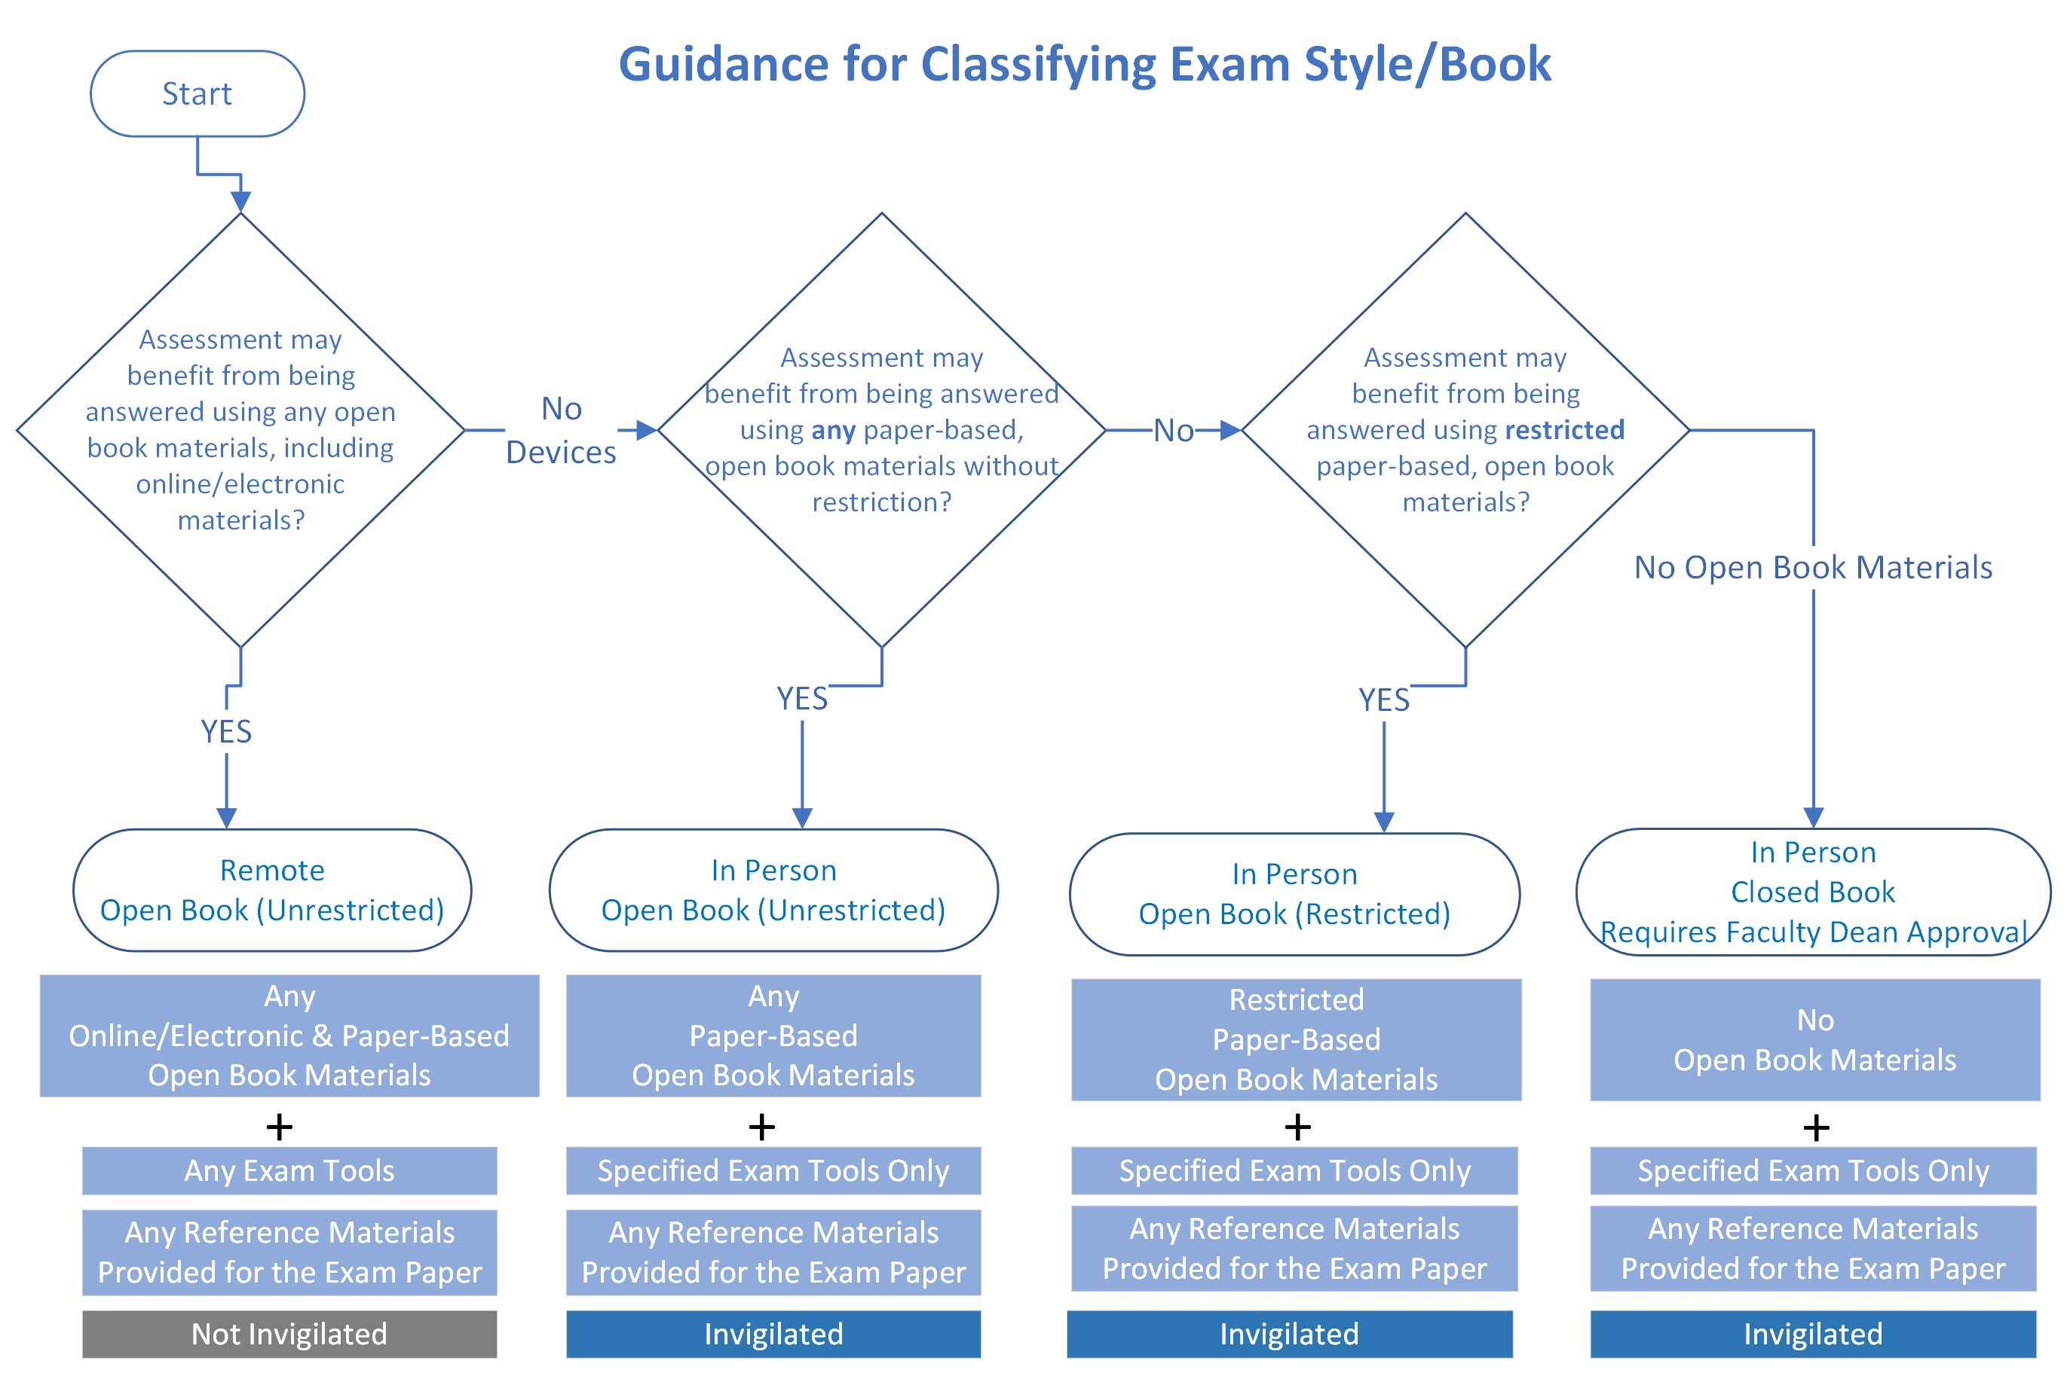
Exam locations
The table below indicates which location to use depending on the exam format.
The Exams Office (exams-staff@essex.ac.uk) can provide further guidance on the correct location for your exam.
Exam Location | Exam Description
Standard | Standard handwritten exam paper (In-person exams only)
Large Desk | Handwritten exam requiring seminar room tables rather than standard desks/ tiered seating (in-person Law exams only)
Moodle Test | Moodle test plus handwritten paper (in-person exams only)
Moodle MCQ | Moodle multiple choice question (MCQ) test
Moodle Test | Moodle test (not MCQ)
Faser | Exam Paper on Faser
Moodle/Mylab | MyLab test via Moodle
QMP Perception | Question Mark Perception (QMP) test
Moodle/Qualtrics | Qualtrics test via Moodle
PC Lab – Special Software | In-person exam requiring access to a specific software

Exam scenarios
The following table provides examples of the types of exam resources that could be used and the subsequent classification that could be required. This list is not exhaustive and Departments should contact the Exams Office for further clarification if needed.
Description | Classification | Reason
Any open book materials, paper or online/electronic. | Remote, Open Book (Unrestricted) | No restriction on any open book materials means exam is remote without restriction. The exam will not be invigilated.
Any paper-based open book materials only (no devices). | In-Person, Open Book (Unrestricted) | Must be in-person if devices accessing online/electronic resources are not permitted and open book (unrestricted) if any paper, open book materials are permitted.
Any open book materials, paper or online/electronic, but want exam to be invigilated. | Would need to choose either:  Remote, Open Book (Unrestricted) without invigilation  or In-Person, Open Book (Unrestricted) without devices | Remote exams are not invigilated and devices accessing online/electronic resources are not permitted in in-person exams. So, a choice must be made depending upon priority of invigilation versus use of online/electronic materials.
Paper study notes only | In-Person, Open Book (Restricted) | Permitting only one item means a restriction is being applied to the open book materials. A page limit can be applied in an open book (restricted) exam if required.
Any paper open book materials but want to specify a page limit on notes. | In-Person, Open Book (Restricted) | Applying a page limit means a restriction is being applied to the open book materials.
Any paper open book materials except textbooks. | In-Person, Open Book (Restricted) | Excluding textbooks means a restriction is being applied to the open book materials.
Formulae/crib sheet only (provided by the department). | In-Person, Open Book (Restricted) | Permitting only one item means a restriction is being applied to the open book materials.
Paper textbook only. | In-Person, Open Book (Restricted) | Permitting only one item means a restriction is being applied to the open book materials.
Case study only. | In-Person, Closed book | A case study is a material provided for the exam paper, not an open book material. As no open book materials have been specified, the exam is closed book and would require Faculty Dean's approval.
Language exam with paper translation dictionary only. | In-Person, Open Book (Restricted) | A translation dictionary is an open book material for a language exam. Permitting only one item means a restriction is being applied to the open book materials.
Non-language exam with paper translation dictionary only. | In-Person, Closed book | A translation dictionary is not an open book material for a non-language exam, it is an exam tool. As no open book materials have been specified, the exam is closed book and would require Faculty Dean's Approval.
Approved calculator only. | In-Person, Closed book | An approved calculator is not an open book material, it is an exam tool. As no open book materials have been specified the exam is closed book.
Approved calculator and formulae sheet only. | In-Person, Open Book (Restricted) | Formula sheet is an open book material. Permitting only one item means a restriction is being applied to the open book materials.
Approved calculator and case study only. | In-Person, Closed book | No open book materials have been specified. The exam is closed book and will require Dean's approval.

Document review information
Document owner | Quality and Academic Development Team
Document last reviewed by | Aminah Suhail, Quality and Academic Development Manager
Date last reviewed | November 2023
Review frequency | Annually

