Clenergy Guide

To Start a Charge
Steps | Example
1st Take the lead out the car and shut all doors and boot lid  2nd PLUG THE LEAD INTO THE CAR FIRST | 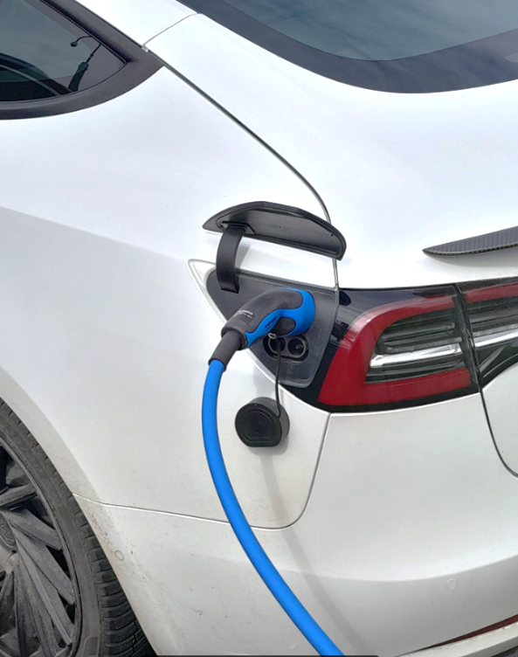
3rd plug the lead into the charge point | 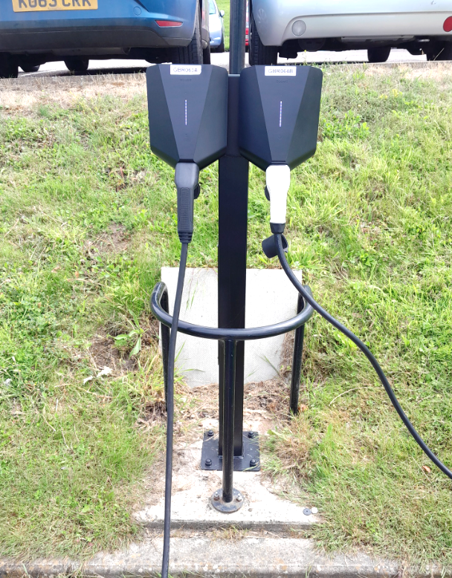
4th Tap the RFID FOB on the reader or start the charge via the app. Ensure your fob serial number is linked to your account | 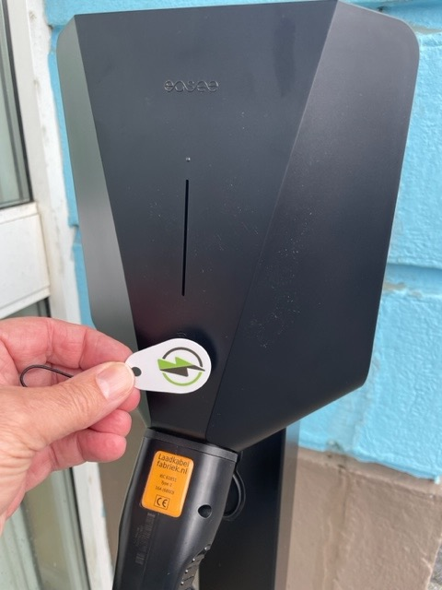

To Stop a Charge
Steps | Example
1st Tap the RFID FOB on the reader or use the app

2nd UNPLUG THE CAR FIRST | 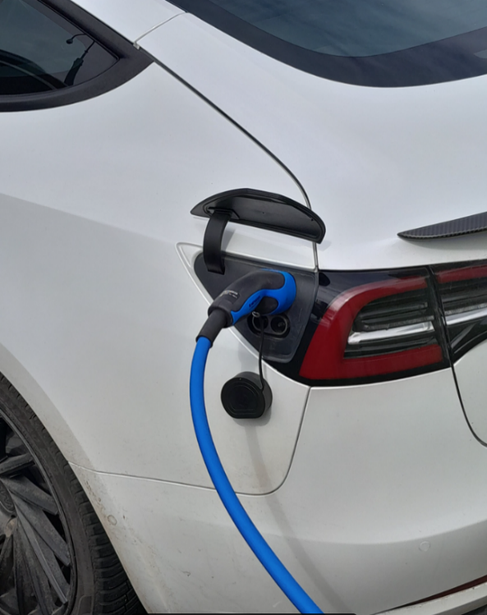
3rd Push the cable into socket slightly and then a positive pull out | 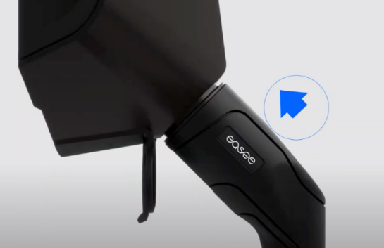

If the cable remains locked in the charge-point
Steps | Example
Step One: Push the cable firmly into the socket | 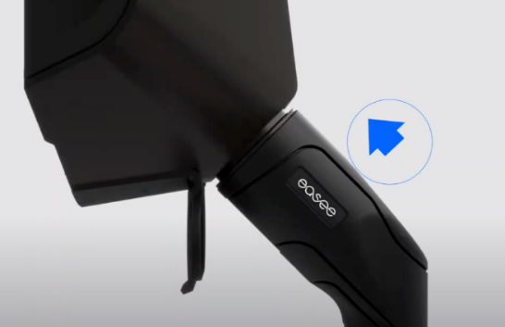
Step 2: Hold the touch button for a few seconds | 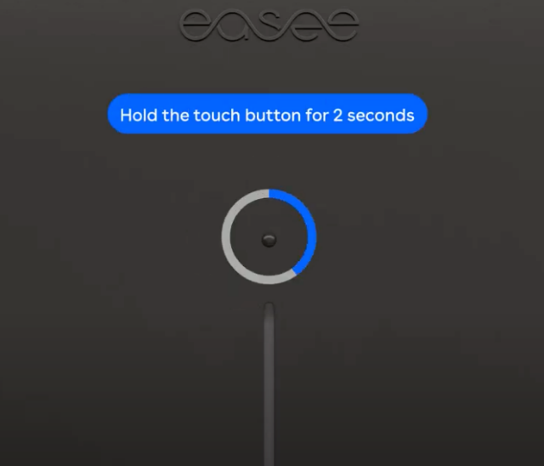
Step 3: While holding the button give a positive pull | 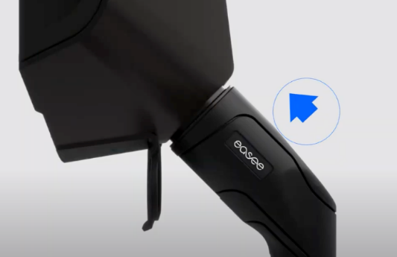

User / Charging problems
Call the 24/7/365 helpline on 0330 232 1111
You will need to quote the GGY reference on the charge point when you call ie: GGY029A
Web: www.essex.ac.uk

