Metacognition
Post 16

To be used alongside the Metacognition 2020 – Post 16 presentation. Please do not skip ahead as this will spoil some of the activities and games.

Name
The Memory Test – Nearpod (Slides 2-4)

Nearpod Activity – if you have access to the internet please complete the activity on www.nearpod.com using the code CYJEI .
You have two minutes to try and match the items together.
When your two minutes are up:
- Think about how you were able to match the items up.
- Did your methods work?
- Make a note below of the method/s you used.

The Memory Game (Slides 5-7)
When your two minutes are up try and write down as many items as you can remember:

Check to see how many you managed to remember and tick them off!
What strategy did you use to remember the items? Did it work?
Based on how many items you remembered, do you think your strategy was effective or not?
Write notes below on your method and other strategies you can think of:

Strategies (Slide 8)
Did you use any of these strategies?
Write down anymore strategies you can think of and how effective they are:

What is Metacognition? (Slide 9)

- Thinking about the ways you think
- Monitoring what you’re doing to see if it works
- Adjusting your strategy if you need to

Metacognition Phases (Slide 10)
Example: Revising for an exam!
Can you think of another example?
Write it down below:

Planning:

Monitoring:

Evaluation:

Metacognition is a life hack! (Slide 11)
- Research shows that metacognition is really effective at boosting your grades
- Metacognition is a transferrable skill
- This skill helps you to develop your independent learning skills.
- It’s not just about what you learn but how you learn it that will really make a difference.

Murder! (Slide 12-13)
You are now going to help with a murder investigation!
Harry was an international celebrity and singer, but he made a lot of enemies. When he realised how much trouble he was in, he disguised himself and headed for sunny Spain, hoping to make a new life… One week later he was found dead on the floor of his hotel room.
Who did it?
The police have drawn up a list of suspects. What they don’t know is which one of them did it. Harry had a hunch about which one person in particular might be on his trail, so he made clues that would help the police find the killer in the event that he was murdered. Now it’s up to you to solve the case.
The ex-friend? The brother? The grandma?

The Memory Game (Slide 14-15)
Think about the strategy you’re going to use – which strategy will help you to remember as many items as possible?
You can use the same strategies you have used beforehand or another one from the notes you have made, or a completely new one! Some will work and some won’t.
Your strategy:

When your two minutes are up, write down all the items you can remember:

The Memory Game (Slide 16)
- How many items did you remember correctly?
- If you used a new strategy did it work?
- Would you use your new strategy again? Or change back to something you did before? Or something completely different?!
This is metacognition: thinking about what works and adjusting accordingly and this will help you learn anything you want to learn, whether that’s college work or something else!

Harry’s Suitcase – any clues? (Slide 17)
Have a look at the items in Harry’s suitcase. Is there anything in there that you think will help solve the case? Click on the items to reveal whether they are a clue.

The Notepad (Slide 18)
Harry knew that if he just wrote down who the killer was, they would see it and destroy it. So he did something clever. He wrote the name of the killer in code in his red notebook and if we can crack this code, then we’ll know who it was who did it.

Crack the Code (Slide 19-20)
Look at the alphabet and you will see, how the letters sit next to who they would rather be!

LX AQNSGDQ

JHKKDC LD

A B C D E F G H I J K L M N O P Q R S T U V W X Y Z

Use the space below to crack the code:

Crack the Code (Slide 19-20)
- Well done if you managed to crack the code successfully!
- If you didn’t quite manage to get it, think about what you tried? What have you realised?
- Write down your thought process, when you were trying to crack the code:

Metacognition Phases (Slide 21)
Fill in the gaps! How did you use metacognition phases to crack the code?

Planning:

Monitoring:

Evaluation:

Strategies (Slide 22)
Have a read through the strategies below. The most effective/useful ones are listed at the top:
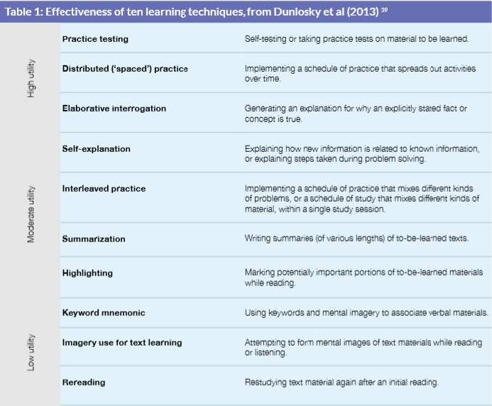

Try explaining what metacognition to a family member or out loud. This is a metacognitive strategy.

In Conclusion (Slide 23)
- Metacognition is about thinking about how you’re learning and changing your strategy if you need to in order to be a really effective learner.
- This will help you to achieve better in exams and will also be helpful in the long-term.
- If you choose to go to university, you’ll be an independent learner and this skill will really help.
- Metacognition isn’t about whether you get the right answer, it’s about working out how you can learn best.

If you have any questions please send them to
www.sli.do and enter #Metacognition and one of the team will get back to you as soon as they can. Alternatively, you can email outreach@essex.ac.uk

My questions/notes

