An Introduction to Referencing

To be used alongside the ‘An introduction to Referencing 2020’ video. Please do not skip ahead as this will spoil some of the activities and games.

Name
What’s in store? (Slide 2)
Objectives
- To understand the importance of referencing
- To be able to identify when a reference is needed
- To successfully identify referencing errors

Notes:

Activity 1: Is a reference needed? (Slide 3)
When is a reference necessary in an assignment? Decide if a reference to a source is needed in the following situations. (Answers given at the end of the booklet)
Situation | Yes | No
- When quoting directly from a published source.
- When using statistics or other data that is freely available from a publicly accessible website.
- When summarizing the cause of undisputed past events and where there is agreement by most commentators on cause and effect.
- When paraphrasing a definition found on a website and when no writer, editor or author’s name is shown.
- When summarizing or paraphrasing the ideas of a key commentator or author, but taken from a secondary source, e.g. general reference book.
- When summarizing in a concluding paragraph of your assignment what you discussed and referenced earlier in your text.
- When including in your assignment photographs or graphics that are freely available on the Internet and where no named photographer or originator is shown.
- When emphasizing an idea you have read that you feel makes an important contribution to the points made in your assignment.
- When summarizing undisputed and commonplace facts about the world.
- When referring to class notes written by the teacher.

Notes:

Which Systems? (Slide 4)
Lots of systems:
- American Psychological Association
- Chicago System
- The Harvard System
- Vancouver
- The Oxford System
- …and so on…

Check whether your project specifies a system and use it!
If a system is not specified then choose one you like
You MUST use only ONE system

Notes:

Harvard Referencing System (Slide 5)
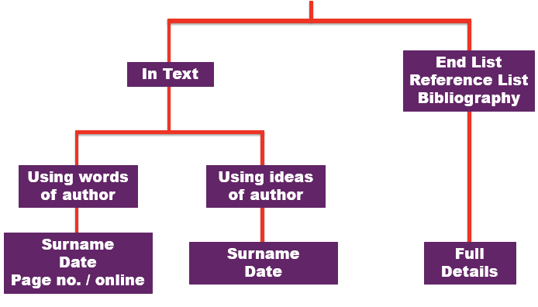
Notes:

Citation vs. Reference list examples (Slide 6)
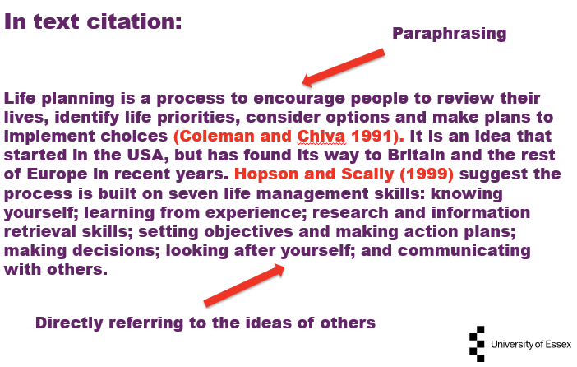

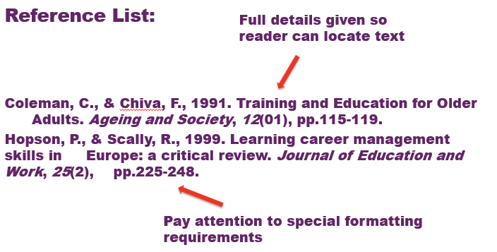

Activity 2: Citation vs. Reference list examples
Where Should the Citations Go? (Answers given at the end of the booklet)
Look at the following three brief extracts from assignments and decide if a citation is necessary, and, if so, where it should go. Mark the relevant point in the text with a X.

- A major study of British school leavers concluded that parents had a major influence on the kind of work entered by their children. The children were influenced over a long period of time by the values and ideas about work of their parents. A later study reached the same conclusion, and showed a link between the social and economic status of parents and the work attitudes and aspirations of their teenage children.
- Climatologists generally agree that the five warmest years since the late nineteenth century have been within the decade, 1995-2005, with the National Oceanic and Atmospheric Administration (NOAA) and the World Meteorological Organization (WMO), ranking 2005 as the second warmest year behind 1998.

It has been argued that federalism is a way of making sense of large organisations and that the power and responsibility that drives federalism is a feature of developed societies and can be extended into a way forward for managing modern business: “authority must be earned from those whom it is exercised”.

Notes:

Activity 3: “I didn’t reference the source because…” (Slide 9)

“I Didn’t Reference the Source Because…” (Answers given at the end of the booklet)
Below are six statements that might be made by students for not referencing a particular source in an assignment. They all start with “I didn’t reference the source because…” However, imagine you were a tutor, what would you say in response to these statements? Six likely tutor responses are shown. Match the likely response to the statement. Write the most likely response number in the right hand column below.
Statements | Response Number:
- I didn’t reference the source in the text of the assignment because I put the source in the bibliography.
- I didn’t reference the source because I found this theory on a Wiki Internet site; anyone can contribute to these, and no particular author is named.
- I didn’t reference the source because the statistics were taken from a government website, which are there for the whole world to see and use.
- I didn’t reference the source because it just gave me ideas to use in my assignment; I changed most of words in the article to my own.
- I didn’t reference the source of the definition because it was from a tutor handout; everyone in class was given a copy.
- I didn’t reference the source because no author or writer’s name was shown on the website.

Responses

- If no named author or writer is shown, you should cite and reference the name of the originator of the source, which can be a name of an organization, or other source.
- Readers need to match in-text citations with the full details of sources in a list of references. This enables readers to find and use the sources for themselves, if required.
- The source of all data like this must be fully referenced. Readers may, for example, want to learn or examine the methodology for the research and data collection.
- It is advisable, wherever possible, to use primary sources in an assignment, rather than secondary sources. A primary source, in this example, would be the originator of the theory. Secondary sources may not always be reliable. However, if you do use a secondary source, it needs to be properly referenced.
- Any source that has played a significant contribution to your assignment must be fully referenced. By doing this you acknowledge the part another person has played in the development of your own ideas.
- This came from work produced by someone else and not by you. It also contributes to the reader’s understanding of terms you have used in your assignment and so needs to be properly referenced.
Notes:

The Internet and Journals: Google Scholar (Slide 11)

Google Scholar: https://scholar.google.com/

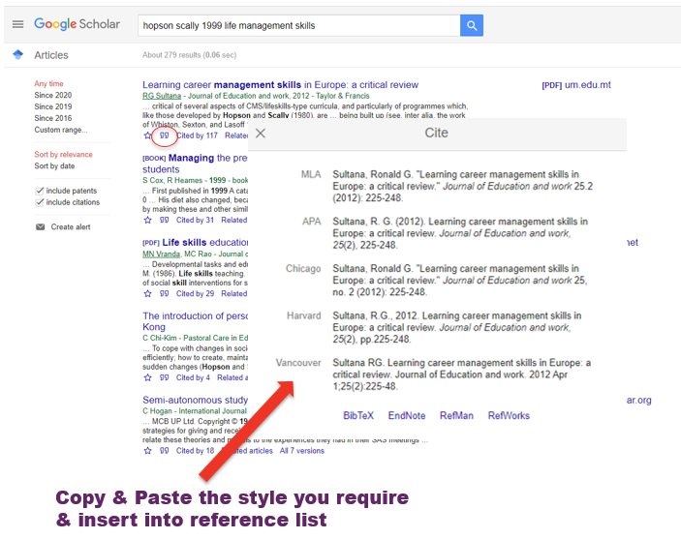
Notes:

Activity 4: Referencing Errors (Slide 12)

A number of the sources below, presented in the Harvard Style of referencing, contain one or more errors. Using your Harvard Referencing guide, identify and summarise in the right hand column below the nature of any errors that you spot.
References | Error(s)?
Http://www.bbc.co.uk/bob/callcentres/ [Accessed 09/08/2004].

BUSINESS STRATEGIES (2000). Tomorrow’s Call Centres: a Research Study.

DEPARTMENT FOR TRADE AND INDUSTRY (2004). The UK Contact Centre Industry: a Study’. [Report]. London: Department for Trade and Industry.

HEALTH and SAFETY EXECUTIVE. Psychosocial Working Conditions in Great Britain in 2004.

HUWS, U (1999). Virtually There: the Evolution of Call Centres. [Report]. London: Mitel Telecom Ltd.

HUWS, U (1993). Teleworking in Britain: a Report to the Employment Department. Research Series No 18, Oct 1993. London: Department of Employment.

HUWS, U (1996). eWorking: an Overview of the Research. [Report]. London: Department of Trade and Industry.

Answers and Comments
Activity 1: Is a Reference Needed?
Situation | Yes | No
- When quoting directly from a published source.

Comment: The sources of all quotations should be referenced.
- When using statistics or other data that is freely available from a publicly accessible website.

Comment: The sources of statistics or other data that you use in assignments should always be referenced.
- When summarizing the cause of undisputed past events and where there is agreement by most commentators on cause and effect.

Comment: This can be regarded as common knowledge, which does not need to be referenced. However, the sources for any contentious discussion of the same events would need to referenced.
- When paraphrasing a definition found on a website and when no writer, editor or author’s name is shown.

Comment: If no named writer, author or editor is shown, you should cite and reference the name of the websit, e.g. Bized 2007.
- When summarizing or paraphrasing the ideas of a key commentator or author, but taken from a secondary source, e.g. general reference book.

Comment: You always need to acknowledge your sources, even if they are secondary ones. However, it is advisable, whenever possible, to consult the main (primary) sources for yourself and to reference these.
- When summarizing in a concluding paragraph of your assignment what you discussed and referenced earlier in your text.

Comment: Providing the sources were properly referenced earlier in your assignment, there would be no need to re-reference your concluding comments. However, any new material introduced into your assignment at this point would need to be referenced.
- When including in your assignment photographs or graphics that are freely available on the Internet and where no named photographer or originator is shown.

Comment: The photographs or graphics are the result of work by another person. In this situation, you should cite and reference the name of the website that contains the illustrations.
- When emphasizing an idea you have read that you feel makes an important contribution to the points made in your assignment

Comment: This is an important reason for referencing, as it acknowledges the importance and relevance of the source concerned to the development of your own work.
- When summarizing undisputed and commonplace facts about the world.

Comment: General public awareness of undisputed facts can also be treated as common knowledge (see also 3, above).
- When referring to class notes written by the teacher.

Comment: You should try to avoid referencing class notes written by the teacher. Instead, you should try to find the original source of the information. However, if you are referring to class notes you must give a reference as you have not produced the work yourself.

Activity 2
1. A major study of British school leavers concluded that parents had a major influence on the kind of work entered by their children X. The children were influenced over a long period of time by the values and ideas about work of their parents. A later study reached the same conclusion, and showed a link between the social and economic status of parents and the work attitudes and aspirations of their teenage children X.

Comment: The above extract refers to two different studies, so you need to cite both of these. You have some flexibility about where the citations should go. For example, the relevant citations could also have been placed after the words ‘study’ in lines 1 and 4. The important point is to make the connection between statement and source as obvious and clear as possible.

2. Climatologists generally agree that the five warmest years since the late nineteenth century have been within the decade, 1995-2005, with the National Oceanic and Atmospheric Administration (NOAA) and the World Meteorological Organization (WMO), ranking 2005 as the second warmest year behind 1998 X.

Comment: The sources of all statistics and information originating from named sources, such as the NOAA and WMO, should always be fully referenced.

3. It has been argued that federalism is a way of making sense of large organisations and that the power and responsibility that drives federalism is a feature of developed societies and can be extended into a way forward for managing modern business: “authority must be earned from those whom it is exercised” X.

Comment: If you use the term, “It has been argued…”, you need to cite who has presented this argument. As a quotation is included, you can show the source of the argument and quotation – assuming they are from the same source – immediately after the quotation. If the quotation is taken from a printed source, show the page number, as well as the author’s name and year of publication, as this helps others to easily locate the quotation in the source cited, e.g. (Handy 1996, p.32),

Activity 3:
“I Didn’t Reference the Source Because…”
Statements | Response number:
- I didn’t reference the source in the text of the assignment because I put the source in the bibliography. | 2  Readers need to match in-text citations with the full details of sources in a list of references. This enables readers to find and use the sources for themselves, if required.
- I didn’t reference the source because I found this theory on a Wiki Internet site; anyone can contribute to these, and no particular author is named. | 4  It is advisable, wherever possible, to use primary sources in an assignment, rather than secondary sources. A primary source, in this example, would be the originator of the theory. Secondary sources may not always be reliable. However, if you do use a secondary source, it needs to be properly referenced.
- I didn’t reference the source because the statistics were taken from a government website - there for the whole world to see and use. | 3  The source of all data like this must be fully referenced. Readers may, for example, want to learn or examine the methodology for the research and data collection.
- I didn’t reference the source because it just gave me ideas to use in my assignment; I changed most of words in the article to my own. | 5  Any source that has played a significant contribution to your assignment must be fully referenced. By doing this you acknowledge the part another person has played in the development of your own ideas.
- I didn’t reference the source of the definition because it was from a tutor handout; everyone in class was given a copy. | 6  This came from work produced by someone else and not by you. It also contributes to the reader’s understanding of terms you have used in your assignment and so needs to be properly referenced.
- I didn’t reference the source because no author or writer’s name was shown on the website. | 1  If no named author or writer is shown, you should cite and reference the name of the originator of the source, which can be a name of an organization, or other source.

Activity 4: Referencing Errors

Http://www.bbc.co.uk/bob/callcentres/ [Accessed 09/08/2004].
Comment: More information is needed; in this example, the name of author or originator and title of item needed to be shown, e.g. BBC (2004). Brassed-off Britain: Call Centres. Available at http://www.bbc.co.uk/bob/callcentres/ [Accessed 09/08/2004].

BUSINESS STRATEGIES (2000). Tomorrow’s Call Centres: a Research Study.
Comment: You need to give details of where this study can be located, e.g. name of publisher or details of website, e.g. BUSINESS STRATEGIES (2000). Tomorrow’s Call Centres: a Research Study. Available at www.businessstrategies.co.uk [Accessed 07/07/2008].

DEPARTMENT FOR TRADE AND INDUSTRY (2004). The UK Contact Centre Industry: a Study’. [Report]. London: Department for Trade and Industry.
Comment: This source is correctly referenced.

HEALTH and SAFETY EXECUTIVE. Psychosocial Working Conditions in Great Britain in 2004.
Comment: the date of publication and detail of publisher is missing. If the text is anything other than a book, you need state what it is, e.g. a report. So the full reference should look like this: HEALTH and SAFETY EXECUTIVE (2004). Psychosocial Working Conditions in Great Britain in 2004. [Report]. London: Health and Safety Executive.

HUWS, U (1999). Virtually There: the Evolution of Call Centres. [Report]. London: Mitel Telecom Ltd.
HUWS, U (1993). Teleworking in Britain: a Report to the Employment Department. Research Series No 18, Oct 1993. London: Department of Employment.
HUWS, U (1996). eWorking: an overview of the research. [Report]. London: Department of Trade and Industry.
Comment: Where you have more than one publication by the same author, these need to be listed in chronological order, with the earliest listed first. So Huws (1993) would be the first listed in this trio of source

Thank you for completing our Independent Study workshop, we hope you enjoyed it and learned something new!
If you have any questions please send them to www.sli.do and enter #Referencing and one of the team will get back to you as soon as they can. Alternatively, you can email outreach@essex.ac.uk
My Questions/Notes

