Developing Research Skills

To be used alongside the ‘Developing Research Skills’ 2020 video. Please do not skip ahead as this will spoil some of the activities.

Name
Learning Objectives (Slide 2)
Objectives
- To have a better understanding of the skills you need to conduct sound research
How will we get there?
- What makes a good researcher?
- What is a literature review? And how do you do one?
- What types of resources are out there?

Notes:

Activity 1: Why are research skills important? (Slide 3)
Brainstorm some of the reasons why you believe research skills are important.

Important for…

Notes:

What is research? (Slide 9)
Notes:

Activity 2: What is research and what type of research is your EPQ? (Slide 10&11)
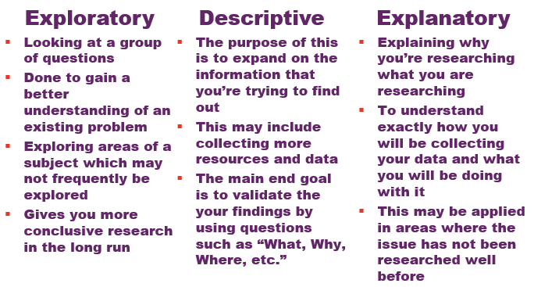
My EPQ will consist of:

Activity 3: What makes a good researcher? (Slide 13)

What makes a good researcher?

Notes:

Activity 4: What sources are out there? (Slide 19)

What sources are out there?

Notes:

The Internet and Journals: Google Scholar (Slides 23- 26)
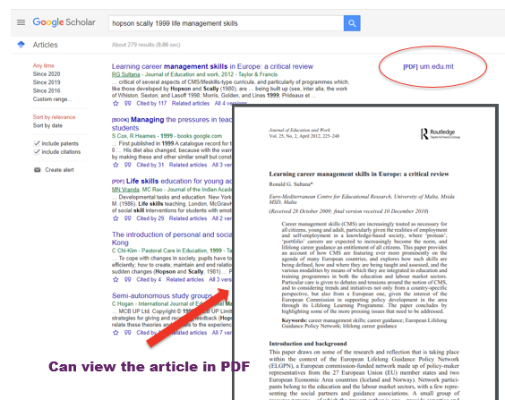
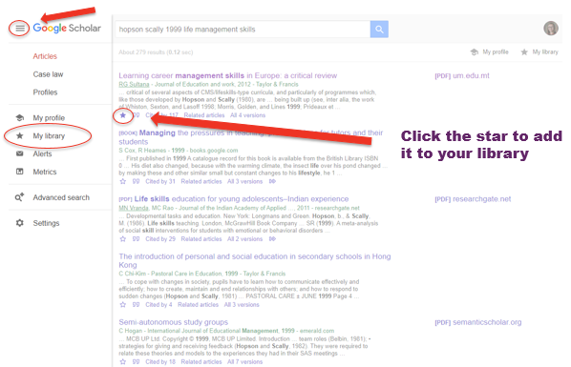

Activity 5: Google Scholar (Slide 27)
Spend some time looking at Google Scholar. You can use this time to start researching your EPQ area if you have decided your topic.
If you haven’t decided what you want to do yet, feel free to look into different topic areas that you’re curious about and see what you can find!
Notes:

How to Evaluate Websites (Slide 28)
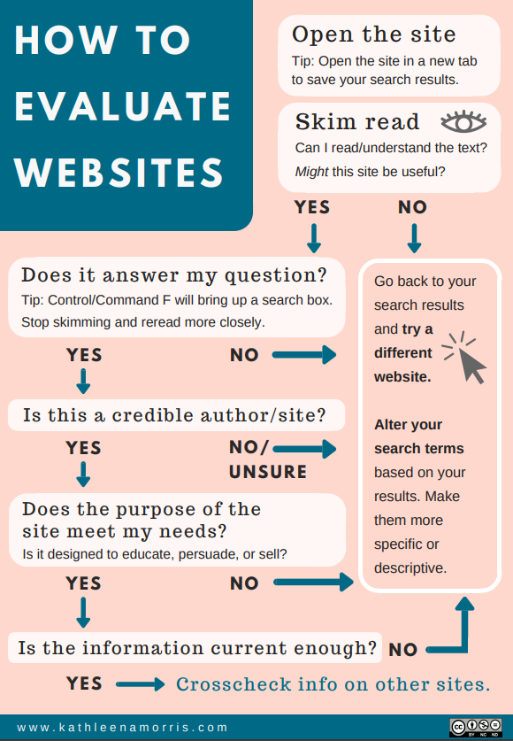
Notes:

Perfect your research skills (Slide 30)
To perfect your research skills remember to:
- Plan and outline what your research will consist of: This will allow you to stay on track and manage it carefully
- Know your sources: ensure your sources are credible! P.S. use the information that we have provided you with.
- Use advanced search techniques: They may take some time to get used to but they will come in handy. Most search engines will give you the option to customize your search results so utilise this!
- Practice: Most importantly, keep practicing in order to see success!
Notes:

Thank you for completing our Developing Research Skills workshop, we hope you enjoyed it and learned something new!
If you have any questions please send them to www.sli.do and enter #ResearchSkills and one of the team will get back to you as soon as they can. Alternatively, you can email outreach@essex.ac.uk
Outstanding Questions/Notes

